medcode inc.

“Health and Technology United“

Holland College CIS-2245

Monday, December 14, 2015

Table of Contents

DOCUMENT CONTROL LOG 3

APPROVAL 4

MANAGEMENT SUMMARY 5

SYSTEM OVERVIEW 6

SYSTEM GOAL STATEMENT 6

SYSTEM DELIVERABLES 9

Overview 9

Deliverables 9

Non-Deliverables 10

Assumptions and Constraints 10

SYSTEM KEY REQUIREMENTS 11

Inputs, Outputs and Data 12

Security 13

SYSTEM MODELING 14

System Use Case Diagrams 14

System Class Diagram 18

System Event Table 19

Primary Use Case, Activity and System Sequence Diagrams 23

Primary Use Case Detailed Descriptions 33

SYSTEM COMPONENTS DETAILS 38

PROGRAM DESIGN 38

Design Class Diagram 38

Sequence Diagram 40

Package Diagram 40

INPUT DESIGN 41

User Interface Designs 42

OUTPUT DESIGN 44

Report Analysis 44

Report Mock-Up Descriptions 44

Report Mock-Ups 46

DATABASE DESIGN 46

Entity Relational Diagram (ERD) 46

Database Description Language (DBDL) 47

Data Dictionary for New Century Clinic 48

Final Table Views w/ Relationships 49

SUPPORT PROCESSING DESIGN 49

Physical Form Documentation 49

Policies & Procedures 50

Financial concerns and considerations 51

ENVIRONMENTAL REQUIREMENTS 53

Hardware & Software Requirements 53

Facility additions and modifications 55

Deployment Diagram 55

IMPLEMENTATION REQUIREMENTS 56

Data Entry 56

Digital Document Creation 57

Security and Levels of Access 58

Access Control 58

Data transfer and usage 59

Physical and Environmental Security 59

Contingency Strategies 60

System Changeover Approach Recommendations 60

Training Requirements 61

Post-implementation review 62

IN-HOUSE VS. OUTSOURCING RECOMMENDATIONS 62

Similar products in the industry 62

In-house vs. Outsourcing approaches 67

Roles of committee members with New Century Clinic 68

APPENDICES 71

Supported Documentation 71

References 71

# DOCUMENT CONTROL LOG

|  |  |  |  |
| --- | --- | --- | --- |
| **Version** | **Date Released** | **Recipients** | **Comments** |
| 1.0 | 14/12/2015 | Gerald Caissy | Specification document created |
| 2.0 | 16/12/2015 | Gerald Caissy | Updated Environmental Requirements, Output Design and Implementation Requirements sections |
| 2.1 | 17/12/2015 | Gerald Caissy | Updated all sections under System Overview |
| 2.2 | 17/12/2015 | Gerald Caissy | Updated all sections under System Components |
| 3.0 | 17/12/2015 | Gerald Caissy | Finalized Specification Document |

# APPROVAL

|  |  |
| --- | --- |
| Client: |  |
|  | Dr. Gerald Caissy, CEO, New Century Clinic |
| System Name: |  |
|  | HuMorIST (**H**ealth **M**edical **I**nsurance **S**ys**T**em) |
| Prepared By: |  |
|  | Christopher Sigouin, Project Manager |
| Project Contributors: |  |
|  | |  |  | | --- | --- | | Christopher Sigouin | Project Manager | | Johnathan Forester | System Analyst | | Luke Fraser | Database Administrator | | Behn McIlwaine | Business Analyst | |

I have thoroughly reviewed the attached documentation regarding HuMorIST and agree with the current proposal. I understand that any changes I request after the signing of this document will impact the delivery of this project and must be handled through the process outlined in this document. I also realize that content of this document is confidential and agree not to divulge system specifics or designs to any third party.

|  |  |
| --- | --- |
| **Client:** | |
|  | |
| ________________________________________ | ________________________________________ |
| Signature | Date |
|  |  |
|  |  |
| **Project Manager:** | |
|  | |
| ________________________________________ | ________________________________________ |
| Signature | Date |

# MANAGEMENT SUMMARY

We have been contacted by New Century Health Clinic to help replace their current office setup. New Century Health Clinic is a doctor’s office with 17 total staff. Staff includes four doctors, three registered nurses, four physical therapists, and six office workers. The clinic manages 3,500 patients, and deals with 275 different employers. With such a broad client base, there is a large amount of paperwork that is required to manage their operations. Office workers are also responsible for compiling reports, sending invoices to patients, and mailing reminders to patients about upcoming appointments. We feel that with a properly implemented system, we can ease the workload on all employees of New Century Health Clinic.

Our proposed system will allow workers to shift away from paper filing, and switch to an information system, where all data is stored in databases. Reports that could take hours to produce can be performed instantaneously due to the setup of the databases. The system will also allow the automation of sending invoices and reminders to patients. On top of these features, the system will also streamline the process of collecting funds from insurance companies. We feel that this will save thousands of hours and multiple thousands of dollars during the lifecycle of our system.

The system will contain 6 computers, all connected to a central server, which will allow employees to access the different subsystems that hold the data. The four subsystems in which everything will be stored is the Patient and Insurance Billing Subsystem, Patient Record Subsystem, Patient Scheduling Subsystem, and Office Order Management subsystem. Within these four subsystems will house the data that supports the business, as well as the methods to access data, retrieve data, modify data, and run automated reports.

For proper setup, New Century Health Clinic’s system will need the following requirements:

* 6 computers (one for each office member)
* A central server that all computers will connect to
* A database, which will have multiple different tables to hold different classes of data
* Local Area Network (LAN) setup, so all computers can communicate
* Internet connectivity, so systems can properly communicate with insurance companies
* A backup unit, so all hardware can be backed up. This will prevent data loss in case of a hardware failure
* Laser printer, and impact printer. These will be set up on the network, so all computers can access.

We estimate the total cost of the system to be roughly $40,448. The timeline for development, installation, and proper training for employees will be roughly three months. Depending on project progression, we will require 1-4 people on-site to install and configure the system, with 1 person on-site during the training period.

# SYSTEM OVERVIEW

## SYSTEM GOAL STATEMENT

We at MedCode believe that with a properly implemented information system, New Century Health Clinic will be able to automate much of their workflow, saving thousands of dollars over the next 5 years. The goal for this system is to keep the office running efficiently, to allow multiple processes to be automated, and allow the company to take on more clients without increasing the employee’s workload.

To properly support all tasks and procedures performed by New Century Health Clinic, we recommend the following be installed for hardware:

* 6 computers (one for each office member)
* A central server that all computers will connect to
* A database, which will have multiple different tables to hold different classes of data
* Local Area Network (LAN) setup, so all computers can communicate
* Internet connectivity, so systems can properly communicate with insurance companies
* A backup unit, so all hardware can be backed up. This will prevent data loss in case of a hardware failure
* Laser printer, and impact printer. These will be set up on the network, so all computers can access.

In addition to this hardware, we propose a setup for 4 distinct systems that will help employees do their duties more efficiently. These systems are:

* Patient Record System
* Patient and Insurance Billing System
* Patient Scheduling System
* Office Order Management System

These systems, when implemented and used, will help employees enter and retrieve data far faster than the current manual setup. The patient record system will provide a location where employees can enter and manage each patient’s records. The insurance and billing system will be able to manage bills, send/receive data from insurance companies, send/receive payments, and automatically issue monthly statements. The patient scheduling system will be able to make the daily list of appointments, as well as manage all upcoming and past appointments. Finally, the office order system will allow office inventory to be maintained, displaying item information, location, and current stock.

All of these systems working together will help keep the office running efficiently, allowing multiple processes to be automated, and freeing up employees to work on other projects. This should also allow the company to take on more clients, without increasing the employee’s workload, due to the automated nature of much of the system.

We also plan on implementing strong security, to keep all of your company and patient information secure from intruders. When dealing the medical records, insurance information, and private data, we want to make sure everything is secure when being stored.

With a properly implemented system that has a life span of 5 years, we expect to save the company money in multiple areas. By installing our system, money can be saved in the following areas:

**New Employee costs**

* Without this system implemented, a new employee will need to be hired.
* With a base salary of $8.50, and a base weekly hour limit of 37.5 hours, the employee would have a $16,575 base salary.
* $82,875 would be saved over 5 years by implementing the system, and not hiring an extra employee.

**Overtime costs**

* Currently, there is enough work for 3 hours of overtime per employee, per week.
* $25.50 extra, per employee, per week. $153.00 total per week for the company.
* $39,780 in overtime pay would be saved over 5 years.

**Errors**

* An average of 3 mistakes are made per day, each taking 20 minutes to fix.
* 1 hour per day to fix.
* Over 5 years, roughly 1306 hours will be saved.
  + $11,092.50 in savings

By installing this system, we estimate the company will save at least $133,747.50 over its 5 year lifespan. We believe that the money can be better spent on other internal projects, or expanding the business, instead of having it spent on tasks that could easily be solved with a info system such as what we’re proposing.

## SYSTEM DELIVERABLES

### Overview

To ensure that our proposal of HuMorIST is clear in what we are providing, we outline below all deliverables that will be provided and not provided. These items are to portray a high level view that is easily understandable and does not present any question as to what is documented.

### Deliverables

|  |
| --- |
| Four computerized systems outlined  Patient Record System  Patient and Insurance Billing System  Patient Scheduling System  Office Order Management System |
| An analysis and design specification document |
| Well implemented analysis diagrams describing the systems functionality |
| Best practice design diagrams |
| Full architectural mapping of system structure |
| Functional designs for data storage |
| Report structures and mock-ups |
| User interface designs |
| Recommended hardware for system implementation |
| Required and recommended policies and procedures |
| Financial overview concerning HuMorIST |
| Data conversion recommendations |
| Security recommendations for system usage |
| Training requirements |
| Research on similar products being used currently |

### Non-Deliverables

|  |
| --- |
| Support of any kind for system functionality and usage after system implementation |
| Any and all hardware required to implement the solution. |
| Updates to any policy and/or procedures provided in provided deliverables |
|  |

### Assumptions and Constraints

*ASSUMPTIONS*:

* Company has decided to computerize its office systems.
* Staff would be trained, by being able to handle routine maintenance tasks without your assistance.
* Regular routine maintenance will be needed in which it consists of file backups, and updating. Tasks will require about four hours per week and can be performed by a clinic staff member. In both cases, the necessary hardware and network installation will cost about $5,000
* A consultant would be hired by Dr. Jones to study the current office systems and recommend a course of action

*CONSTRAINTS*:

* If needed the problem with work overload would be solved with additional office clerk
* Company's current workload requires three hours of office staff overtime per week at a base rate of $8.50 per hour.
* The current manual system also causes an average of three errors per day, and each error takes about 20 minutes to correct.
* If designed the new system as a database application, you can expect to spend about $2,500 for a networked commercial package.
* New Century probably will need you to provide about 10 hours of initial training and support each week for the first three months of operation

## SYSTEM KEY REQUIREMENTS

Concerning system key requirements, if New Century wants to create an appointment with a patient, they must access the Patient Record System which will include the appointment number to link to the patient that they must choose to access the patient’s records.

If New Century wants to schedule an appointment, they must access the Patient Scheduling System and select “scheduled appointment data”.

If New Century wants to charge the patient for the appointment, they must access the Patient and Insurance Billing System for their insurance, patient number, and CPT codes to find the patient information and how much they are going to charge. This is based on the fee found in the Patient and Insurance Billing System.

### Inputs, Outputs and Data

Below we outline all inputs, outputs and data based on system type.

|  |  |  |  |
| --- | --- | --- | --- |
| Patient Record System | Inputs | Outputs | Data |
|  | Appointment Number | Appointment Data, Appointment Start & End time | Appointment Information |
|  | Patient Number | Provider Number | Client Number |
|  | Patients | Patients Number, Last name, First name, Birthdate , Last exam | Client Information |

|  |  |  |  |
| --- | --- | --- | --- |
| Office Order Management System | Inputs | Outputs | Data |
|  | MTD (Month to date) Payments | Office reports and outputs | MTD (Month to date) Reports |
|  | Supplies | Overview what's available | Overview of Inventory |
|  | Stockage | How much is available | Overview of Stock |

|  |  |  |  |
| --- | --- | --- | --- |
| Patient and Insurance Billing System | Inputs | Outputs | Data |
|  | Insurance | Carrier data, change, claim data, company report, update, payment | Insurance data |
|  | Insurance Carriers | Co. Number, Co Name, Address 1 , Address 2, Zip, Phone | Insurance Personal Information |
|  | Patient Number | Provider Number | Patient Insurance Company |
|  | MTD(Month to date) charges | Appt. Number, CPT(**Current Procedural Terminology**) code, Provide number, fee |  |
|  | Total Charges | Claim, Claim status Summary | Claim Charges |
|  | Providers | Provider Number, Name, Charges YTD (Year to date) , MTD(Month to date) | Provider report  YTD (Validation of patient charges) |
|  | CPT(**Current Procedural Terminology**) Codes | CPT Fee schedule (Tracking) | CPT overview |

|  |  |  |  |
| --- | --- | --- | --- |
| Patient Scheduling System | Inputs | Outputs | Data |
|  | Scheduled appointment data | Appointment Number, Appointment Date, Start Time, End time, Patient Number, Provider Number | Schedule Information |
|  | Reminder | Reminder Postcard data (Phone and/or email) | Reminder Appointment |

### Security

Security rules

* Implement appropriate protection, such as strong encryption and data masking to prevent unauthorized exposure and at worst, malicious use.
* The user should appropriate privileged user roles with careful attention to their duties.
* Monitor data access, with particular attention to the activities of privileged users, such as database administrators
* Identifying the applications that have access to PHI, validating whether that access is appropriate, as well as the individuals, groups and organizations authorized to use those applications, with appropriate limitations.
* Implement logging, audit and reporting capabilities around application and data access, administrative functions; user and asset access activity, provisioning and de-provisioning

## SYSTEM MODELING

### System Use Case Diagrams

Our proposed system will be comprised of 4 major subsystems:

1. Office Order Management Subsystem – System based around office stock.
2. Patient and Insurance Billing Subsystem – System based around billing, and receiving funds.
3. Patient Record Subsystem – System based around storing and managing patient information.
4. Patient Scheduling Subsystem – System based around booking appointments for clients.

As follows is a breakdown of use cases for each subsystem.

#### Office Order Management Subsystem

Only office workers will be interacting with this subsystem, as it is a subsystem designed for office supply tracking. Workers will be able to create new inventory items, edit items, generate reports on the inventory, as well as view low stock.

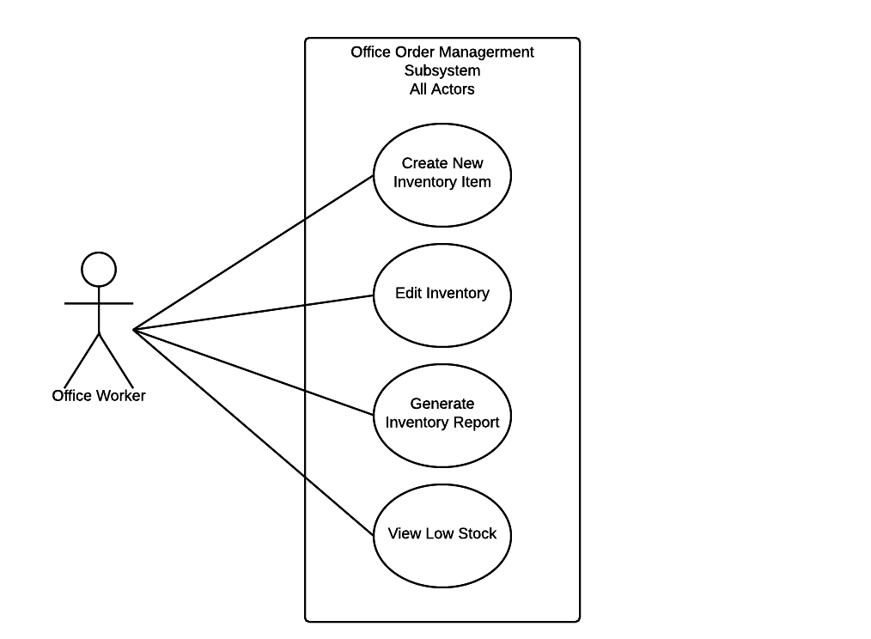

#### Patient and Insurance Billing Subsystem

One of the more important subsystems is the one that handles invoicing patients, and receiving funds from insurance companies. Office workers will be able to receive funds, generate or view invoices, and generate or view insurance reports. Patients and Insurance agents will also be able to access parts of this system. Insurance Agents will be able to send funds, as well as view insurance reports. Patients will be able to send funds, and view their invoice.

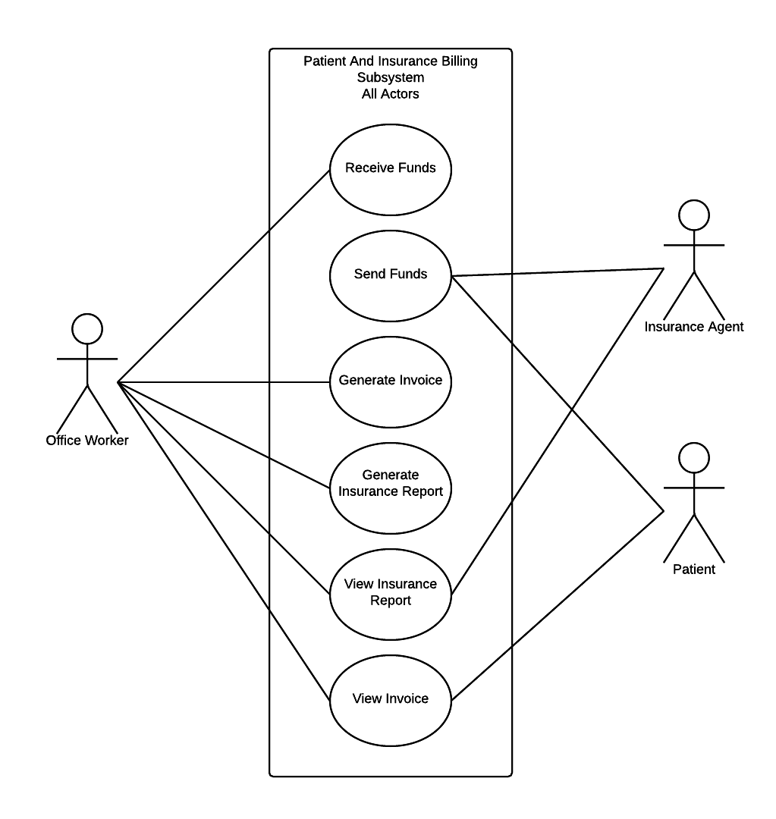

#### Patient Record Subsystem

Arguably the most important subsystem, the patient record subsystem allows office workers to add, update, and view patient records. While it is a simple system, this system facilitates the storage of all patient data. This patient data is used across most other subsystems, so this subsystem is critical to have working.

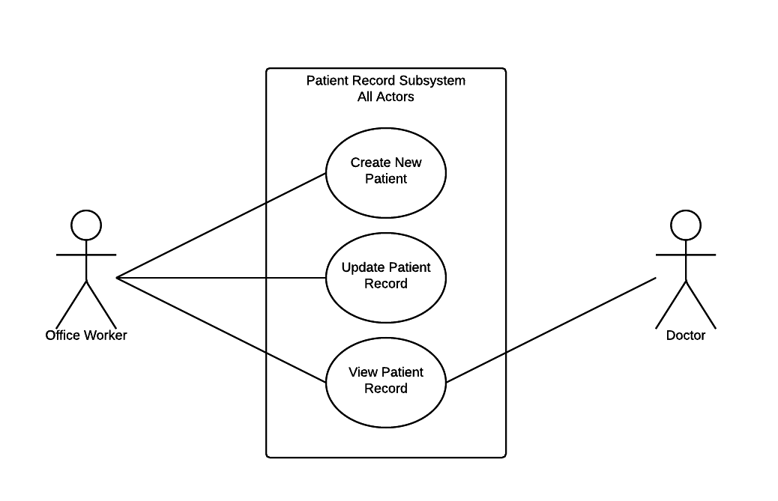

#### Patient Scheduling Subsystem

When a patient requests a new appointment, this is the subsystem that will be able to handle it. Office workers will be able to create new appointments, edit or view individual appointments, view all daily appointments, and view the entire history of all appointments. Patients will also have the ability to view their appointments.

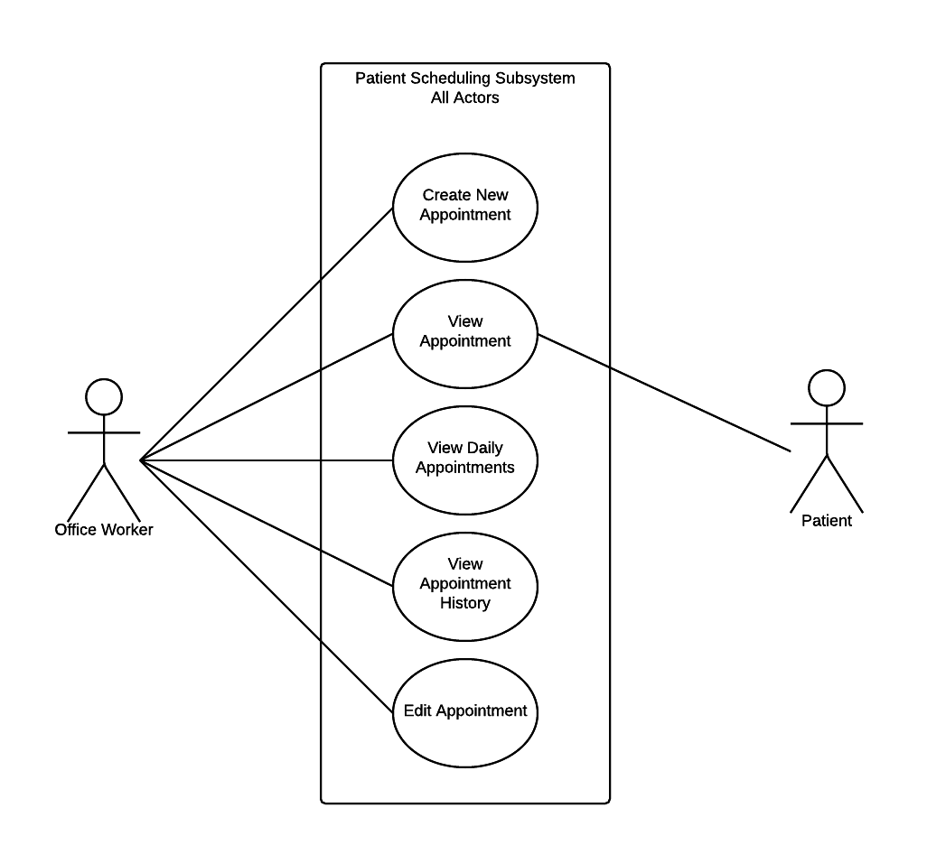

### System Class Diagram

As follows is the System Class Diagram for our proposed system. Each class is specified, its attributes are listed and it’s relation to other classes is specified. As you can see, the Patient class is tied into many other classes, as it is related to most other classes in one form or another.

The Patient class is the most important of all classes, and a higher priority should be taken to make sure this class is functioning properly.

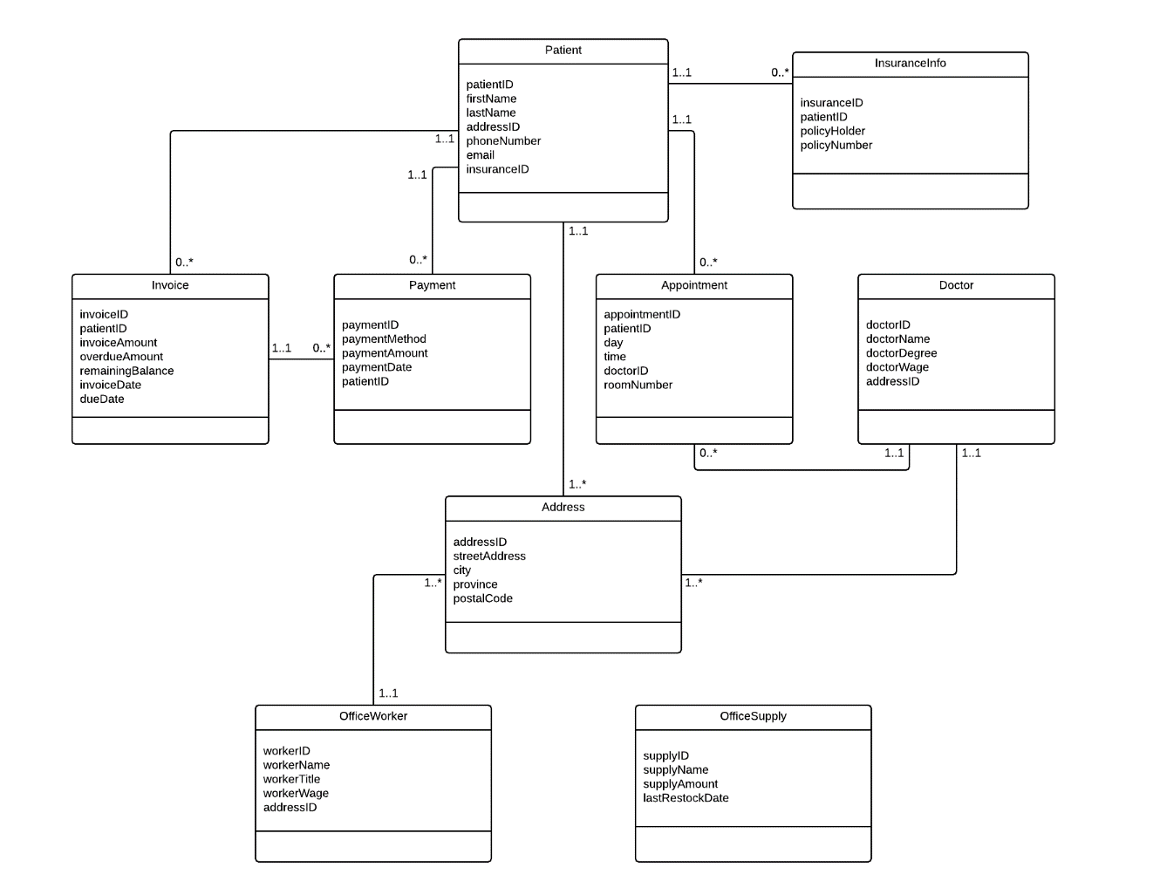

### System Event Table

There are certain expected events that will occur when users incorporate these systems into their workflow. For each event, there is an associated use case, as explained above. Next, you will find a chart breakdown of each event for each subsystem, and the related use case that will apply to it.

Patient Scheduling System

|  |  |  |  |
| --- | --- | --- | --- |
| Event | Trigger | Source | Use Case |
| Employee adds new appointment | New Appointment | Office Worker | Create new appointment |
| Employee views existing appointment | Display Appointment | Office Worker | View Appointment |
| Patient views existing appointment | Display Appointment | Patient | View Appointment |
| Employee views all appointments for a day | Display Daily Appointment | Office Worker | View Daily Appointments |
| Employee views appointment history | Display All Appointments | Office Worker | View Appointment History |
| Employee edits existing appointment | Edit Appointment Notice | Office Worker | Edit Appointment |

Patient Record System

|  |  |  |  |
| --- | --- | --- | --- |
| Event | Trigger | Source | Use Case |
| Employee creates new patient | New Patient | Office Worker | Create New Patient |
| Employee edits existing patient | Edit Patient Notice | Office Worker | Update Patient Record |
| Employee views patient record | Display Patient Record | Office Worker | View Patient Record |
| Doctor views patient record | Display Patient Record | Doctor | View Patient Record |

Patient & Insurance Billing System

|  |  |  |  |
| --- | --- | --- | --- |
| Event | Trigger | Source | Use Case |
| Employee receives sent funds | Payment Received Notice | Office Worker | Receive Funds |
| Patient pays for bill | Payment Received Notice | Patient | Send Funds |
| Insurance company pays for bill | Payment Received Notice | Insurance Agent | Send Funds |
| Employee manually generates invoice | Print Invoice | Office Worker | Generate Invoice |
| Employee creates insurance report | Create Report | Office Worker | Generate Insurance Report |
| Insurance Agent views insurance report | View Report | Insurance Agent | View Insurance Report |
| Employee views insurance report | View Report | Office Worker | View Insurance Report |
| Employee views invoice | View Invoice | Office Worker | View Invoice |
| Patient views invoice | View Invoice | Patient | View Invoice |

Office Order Management System

|  |  |  |  |
| --- | --- | --- | --- |
| Event | Trigger | Source | Use Case |
| Employee creates new inventory item | Create New Item | Office Worker | Create New Inventory Item |
| Employee takes stock and enters results | Update Inventory | Office Worker | Edit Inventory |
| Employee views inventory report | View Inventory | Office Worker | Generate Inventory Report |
| Employee views only low stock | View Low Inventory | Office Worker | View Low Stock |

Automated Reports

|  |  |  |  |
| --- | --- | --- | --- |
| Event | Trigger | Source | Use Case |
| Time to send invoice to patient | “Two weeks after appointment” | System | Generate Invoice |
| Time to get daily appointments | “Daily” | System | View Daily Appointments |
| Time to produce call list | “Daily” | System | Generate Call List |
| Time to produce provider report | “Every Monday” | System | Generate Provider Report |
| Time to produce insurance report | “Every Monday” | System | Generate Insurance Report |
| Time to produce claims status summary | “On the first day of the month” | System | Generate Claims Status Summary |
| Time to produce shipping labels | “Every second Monday” | System | Print Shipping Labels |

### Primary Use Case, Activity and System Sequence Diagrams

Next, we will be highlighting some of the most important use cases in each subsystem. For each use case, we will be presenting a use case diagram, an activity diagram, and a sequence diagram. This will allow a full breakdown of each case, including the logic behind it, and the system classes it must interact with.

#### Create New Appointment

This use case is for creating new appointments. As you can see in the use case diagram, the office worker is simply running through the Create New Appointment use case.

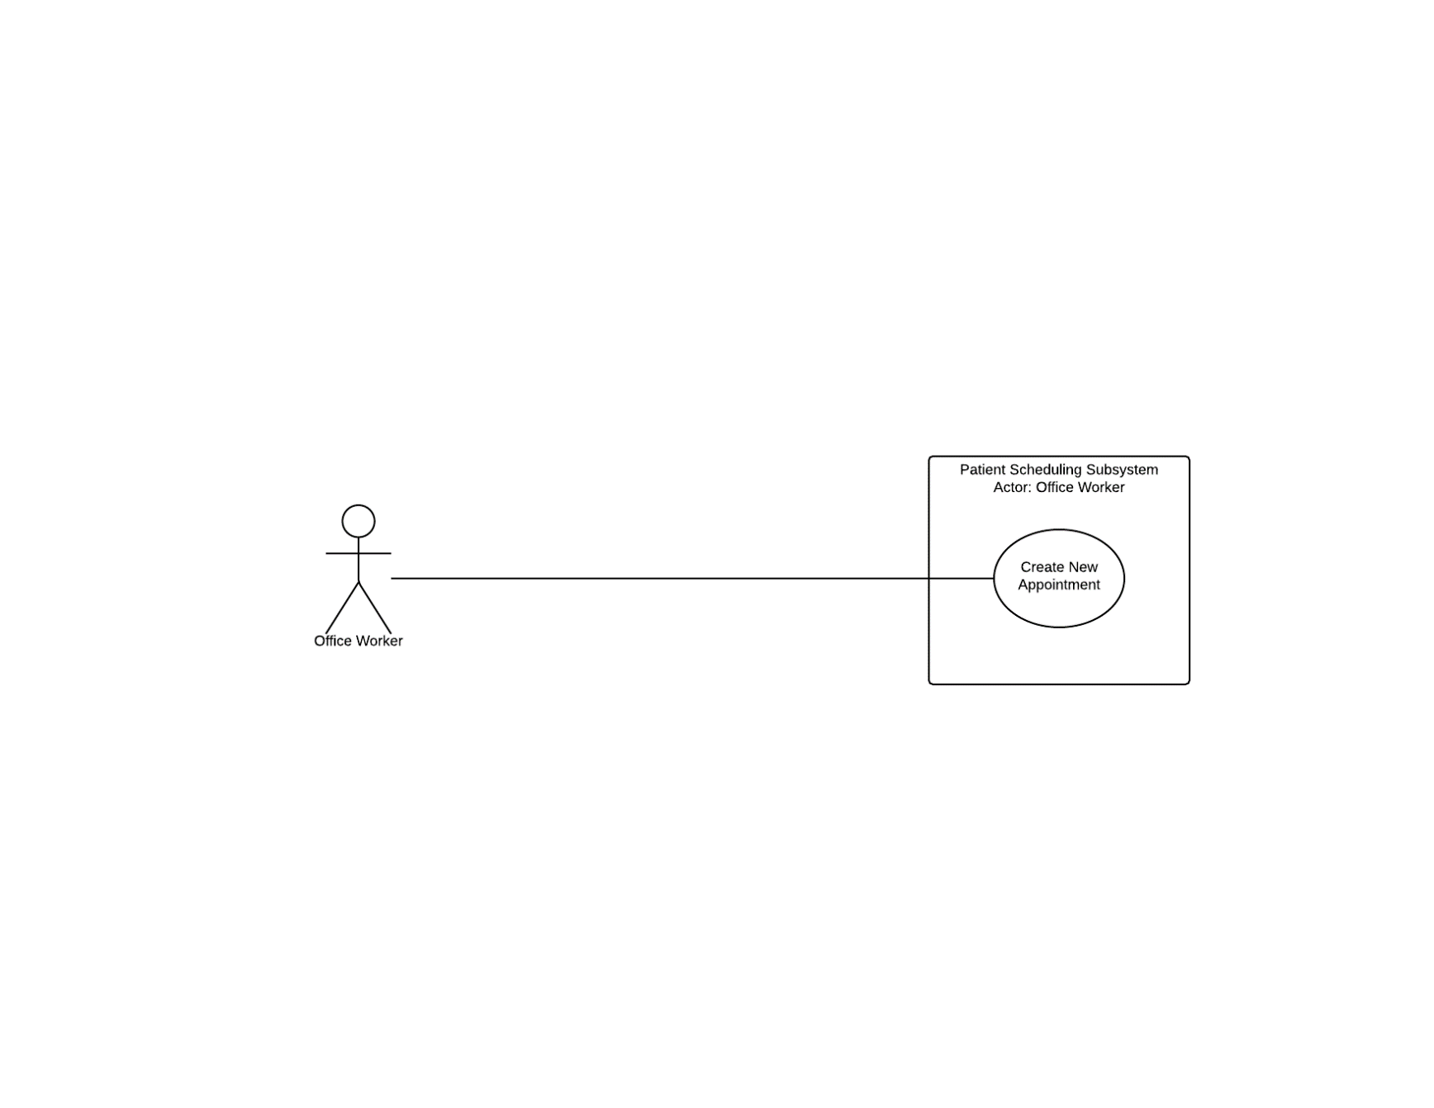

Here is the logic that goes into this process. After the appointment is requestied, there is a check to make sure that the appointment doesn’t already exist. After this, the system checks to make sure the time isn’t taken. If both are fine, the appointment is created. However, if either fail, the user is prompted to enter a new appointment.

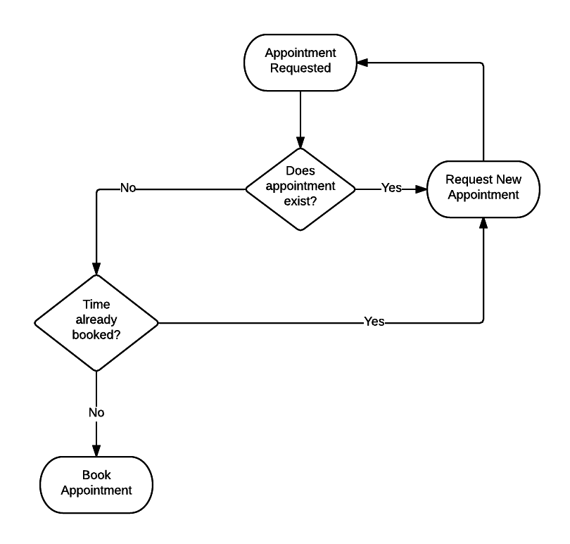

Finally, we have the sequence diagram. It is a fairly simplistic sequence of evemts. The worker provides the day, time, and patient ID that the appointment will be booked for. The system responds with a confirmation of the booking.

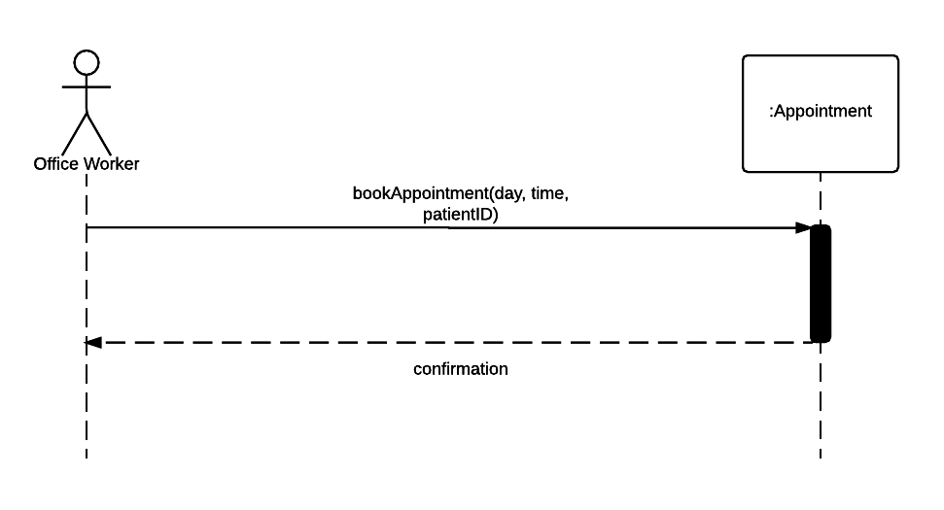

#### Create New Patient

This use case is for creating new appointments. As you can see in the use case diagram, the office worker is simply running through the Create New Patient use case.

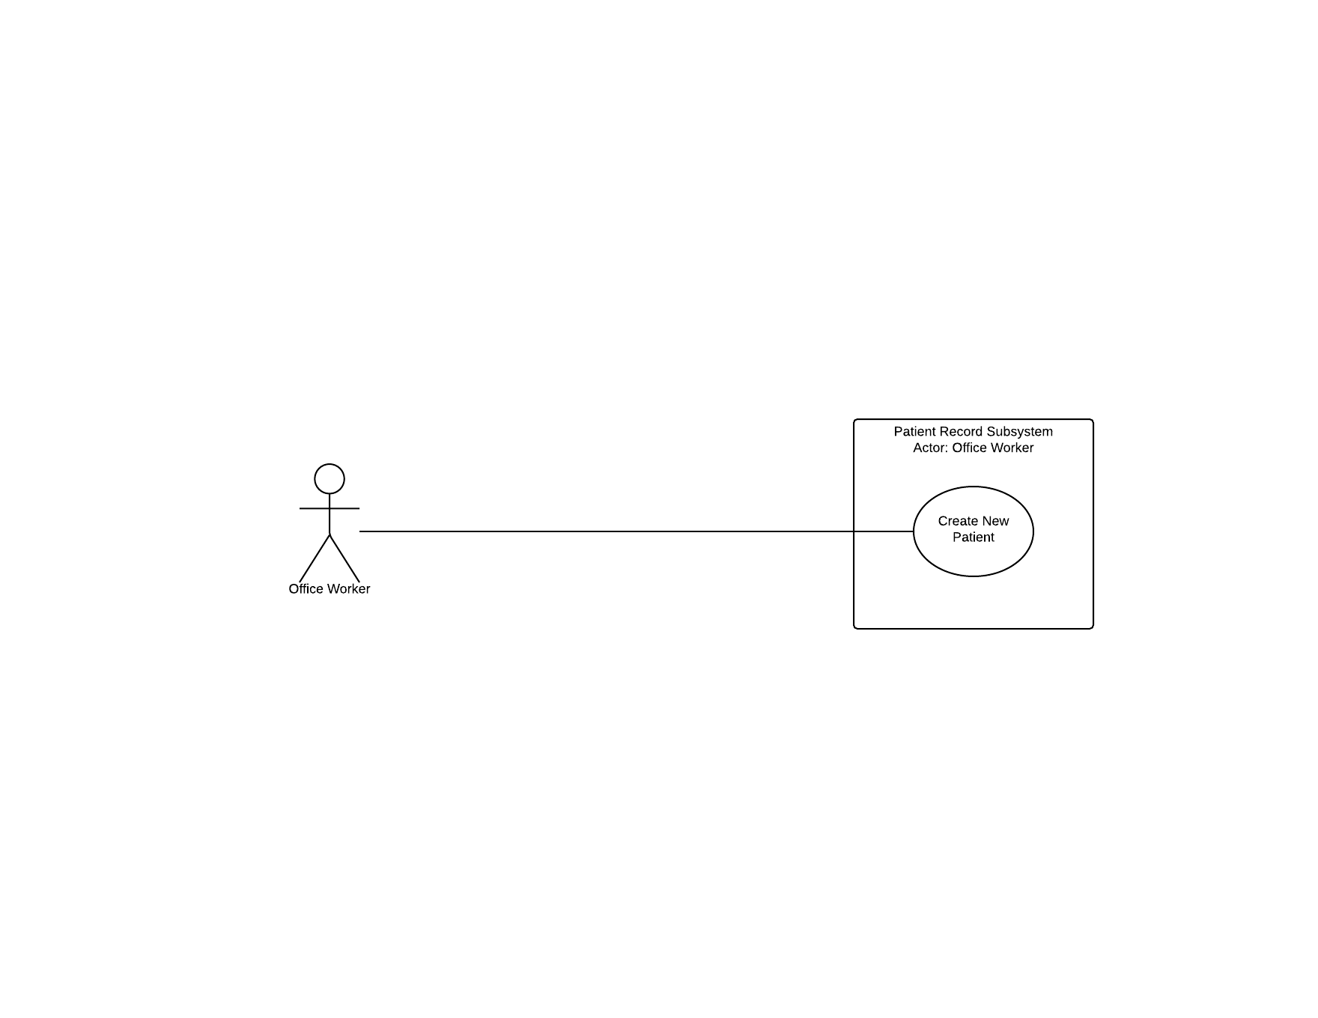

Here is the logic that goes into this process. After the patient information is gathered and entered, a check is done to make sure the name doesn’t already exist in the system. Once the rest of the patient information is confirmed, and new entry it made. If a duplicate name exists in the system, the user is asked to confirm if it is the same patient of not. If it’s a new patient, a new record is created after verifying info.

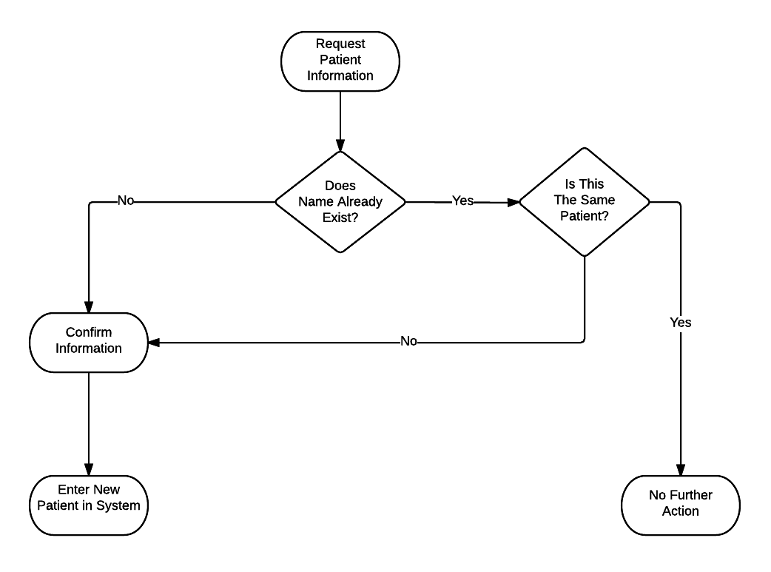

Finally, we have the sequence diagram. It is a fairly simplistic sequence of evemts. The worker provides the information about the patient they are creating. The system responds with a confirmation of the patient being created.

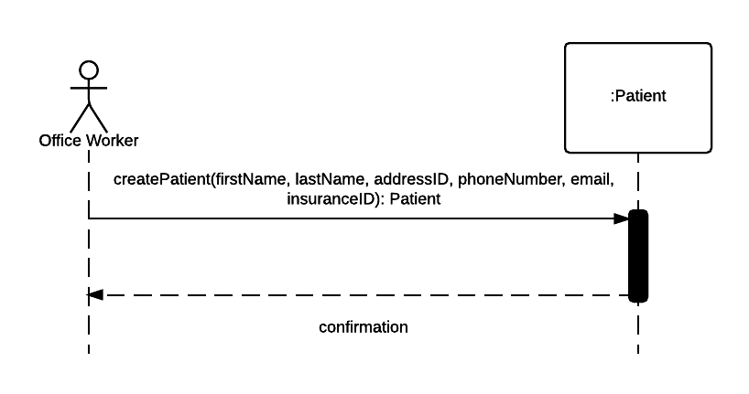

#### Receive Funds

This use case is for receiving funds. As you can see in the use case diagram, the office worker is simply running through the Create New Patient use case. The Insurance agent also interacts with the subsystem.

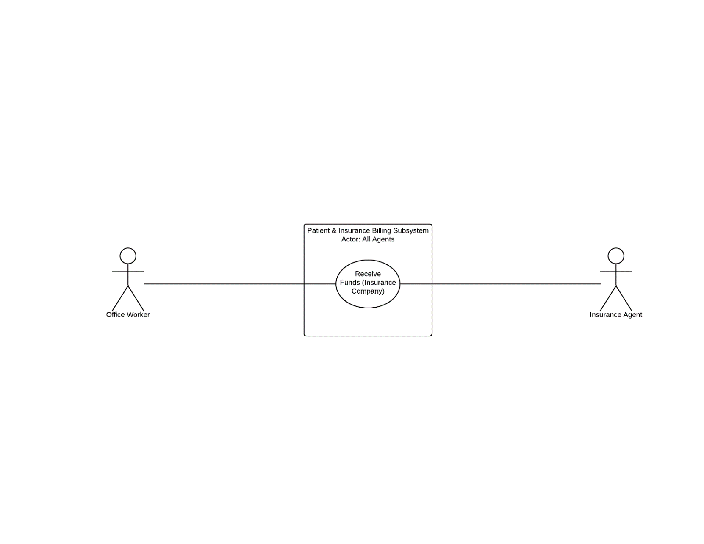

Here is the logic that goes into this process. After the funds are received for a client, the patient records are checked to make sure that funds are owed. If so, the funds are applied to the account, and any potential leftover funds are returned to the insurance company. If no funds are owed for the patient in the initial check, the funds are returned to the insurance company.

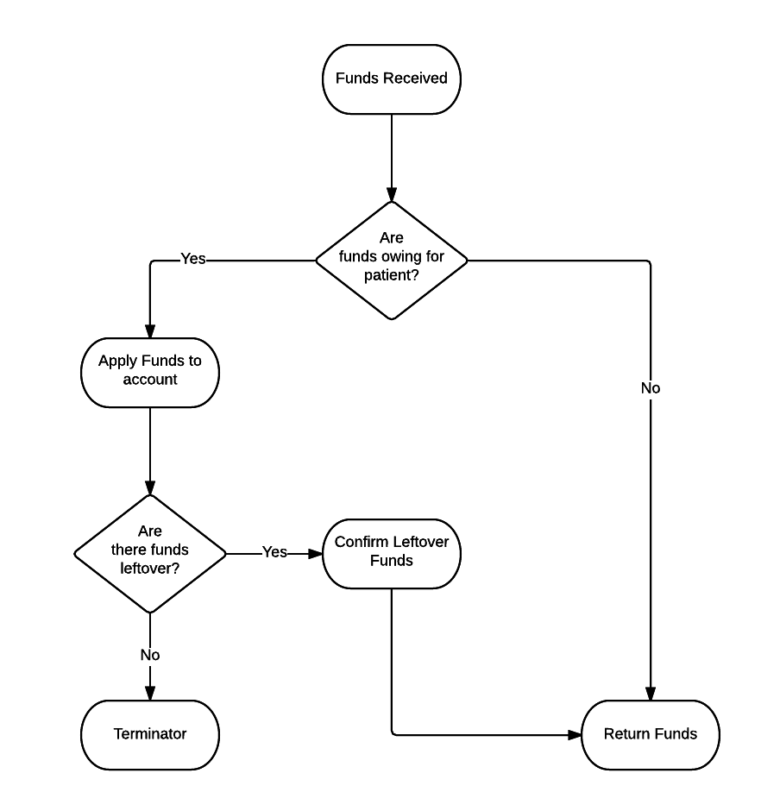

Finally, we have the sequence diagram. This sequence requires accessing information in two classes, Payment and Invoice. The worker queries for available payments, which grabs information about a received payment. The info gathered allows the funds to be applied to Invoice class, and confirms this to the worker.

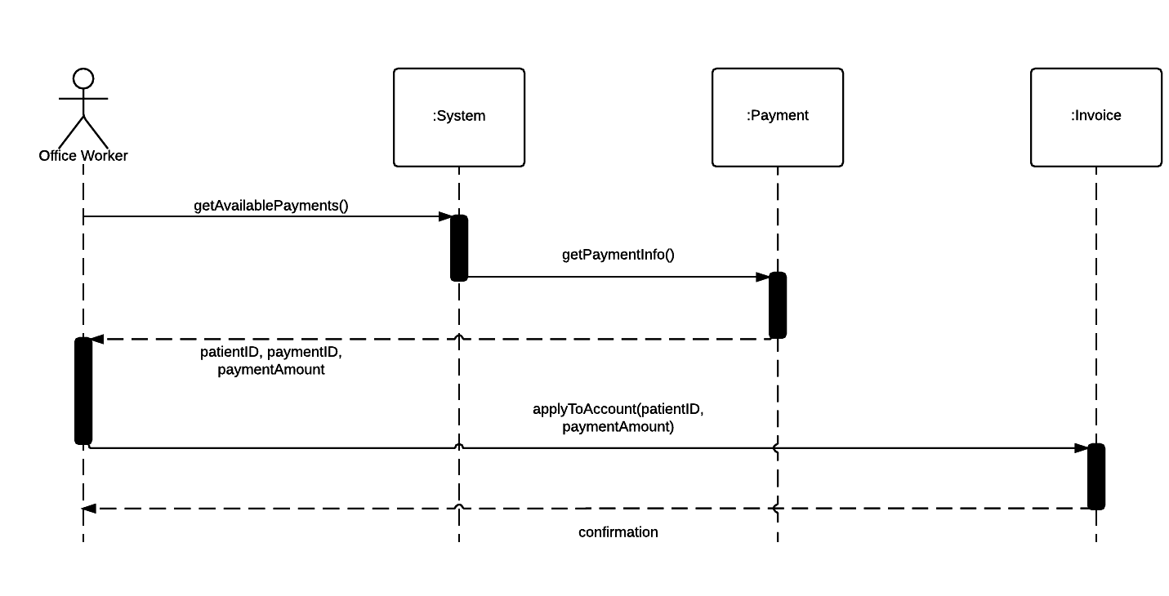

#### Update Office Inventory

This use case is for updating inventory. As you can see in the use case diagram, the office worker is simply running through the Update Office Inventory use case.

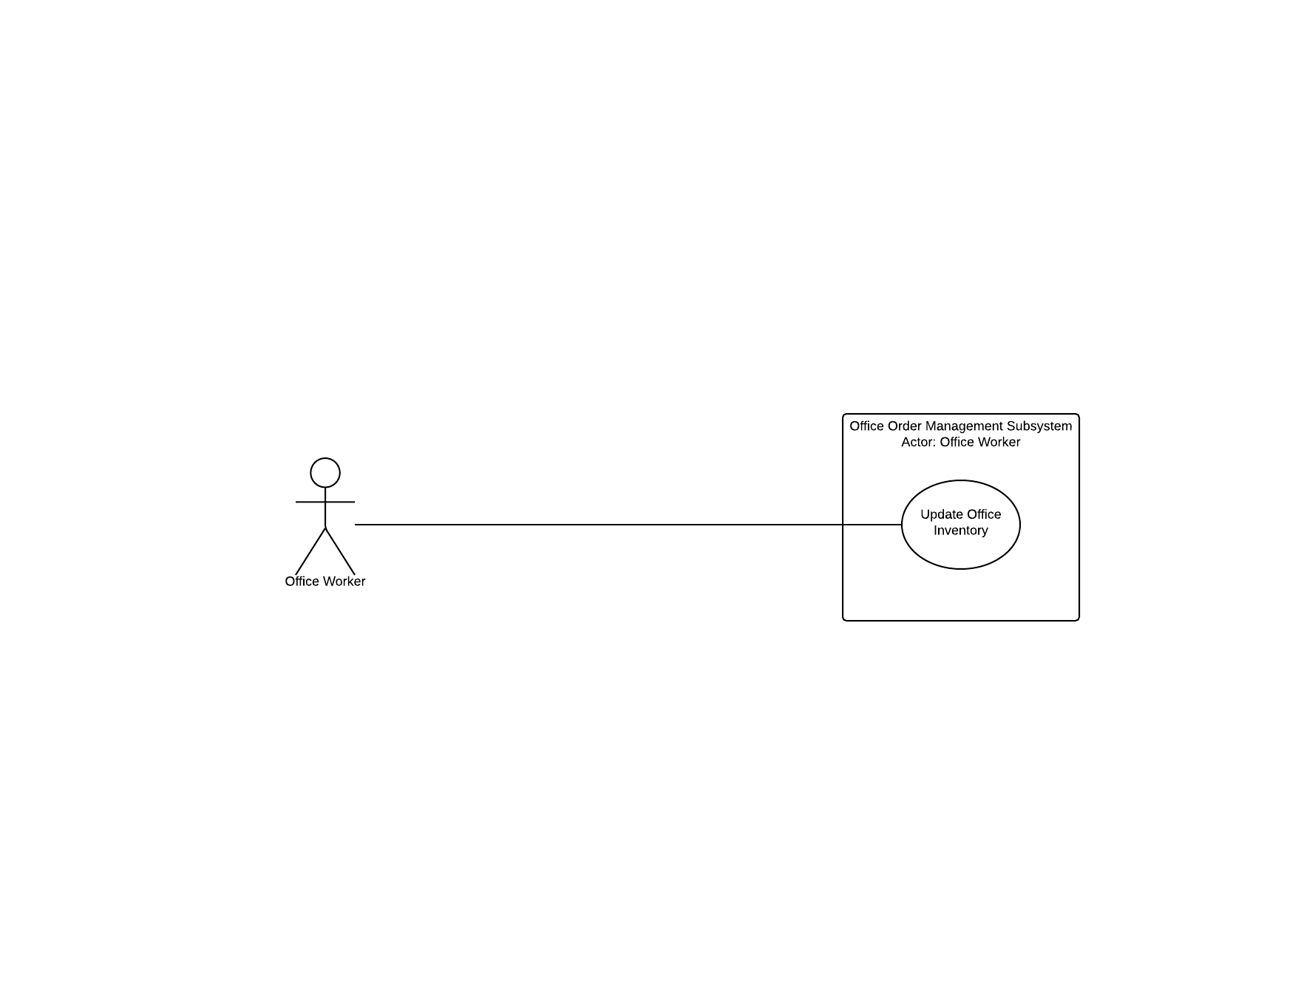

Here is the logic that goes into this process. After the item is specified, a check is made to make sure it doesn’t already exist (if it does exist, the user is prompted to make a new choice). If it does exist, the user is prompted for stock, and the stock is updated. After updating, the user is prompted to make another entry.

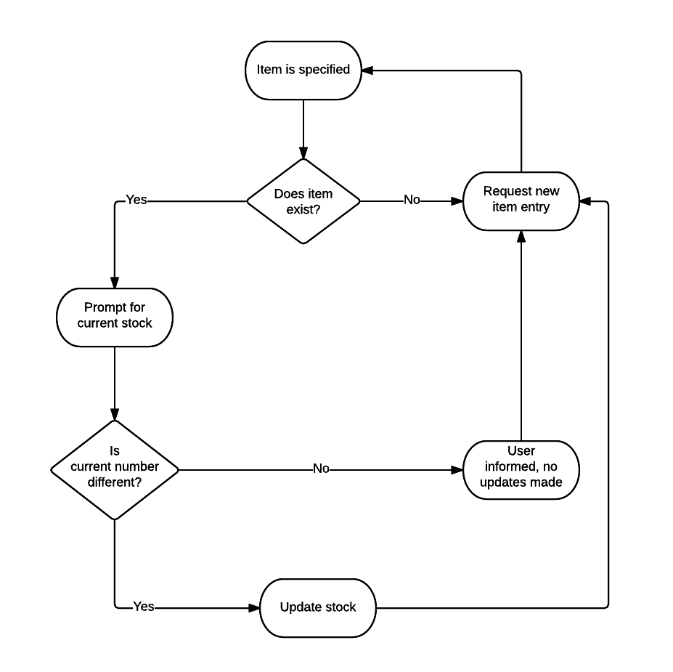

Finally, we have the sequence diagram. This sequence requires accessing information in the OfficeSupply class. After supplying the supplyID to update, the user is prompted for a new stock number. After sending the new stock amount, the user receives confirmation of the update.

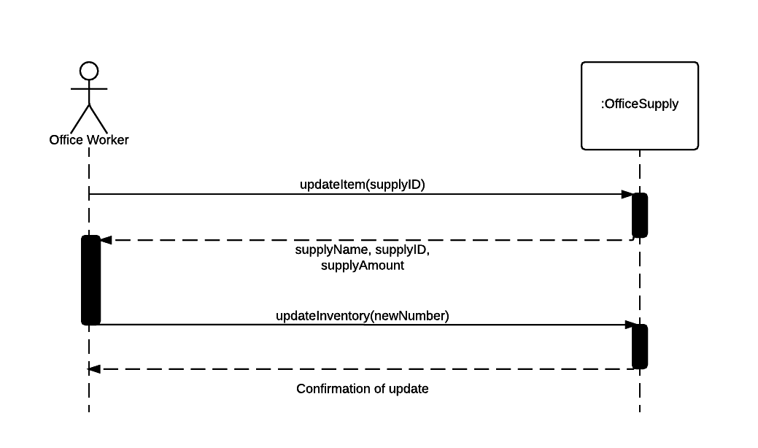

#### Update Patient Information

This use case is for updating inventory. As you can see in the use case diagram, the office worker is simply running through the Update Patient Information use case.

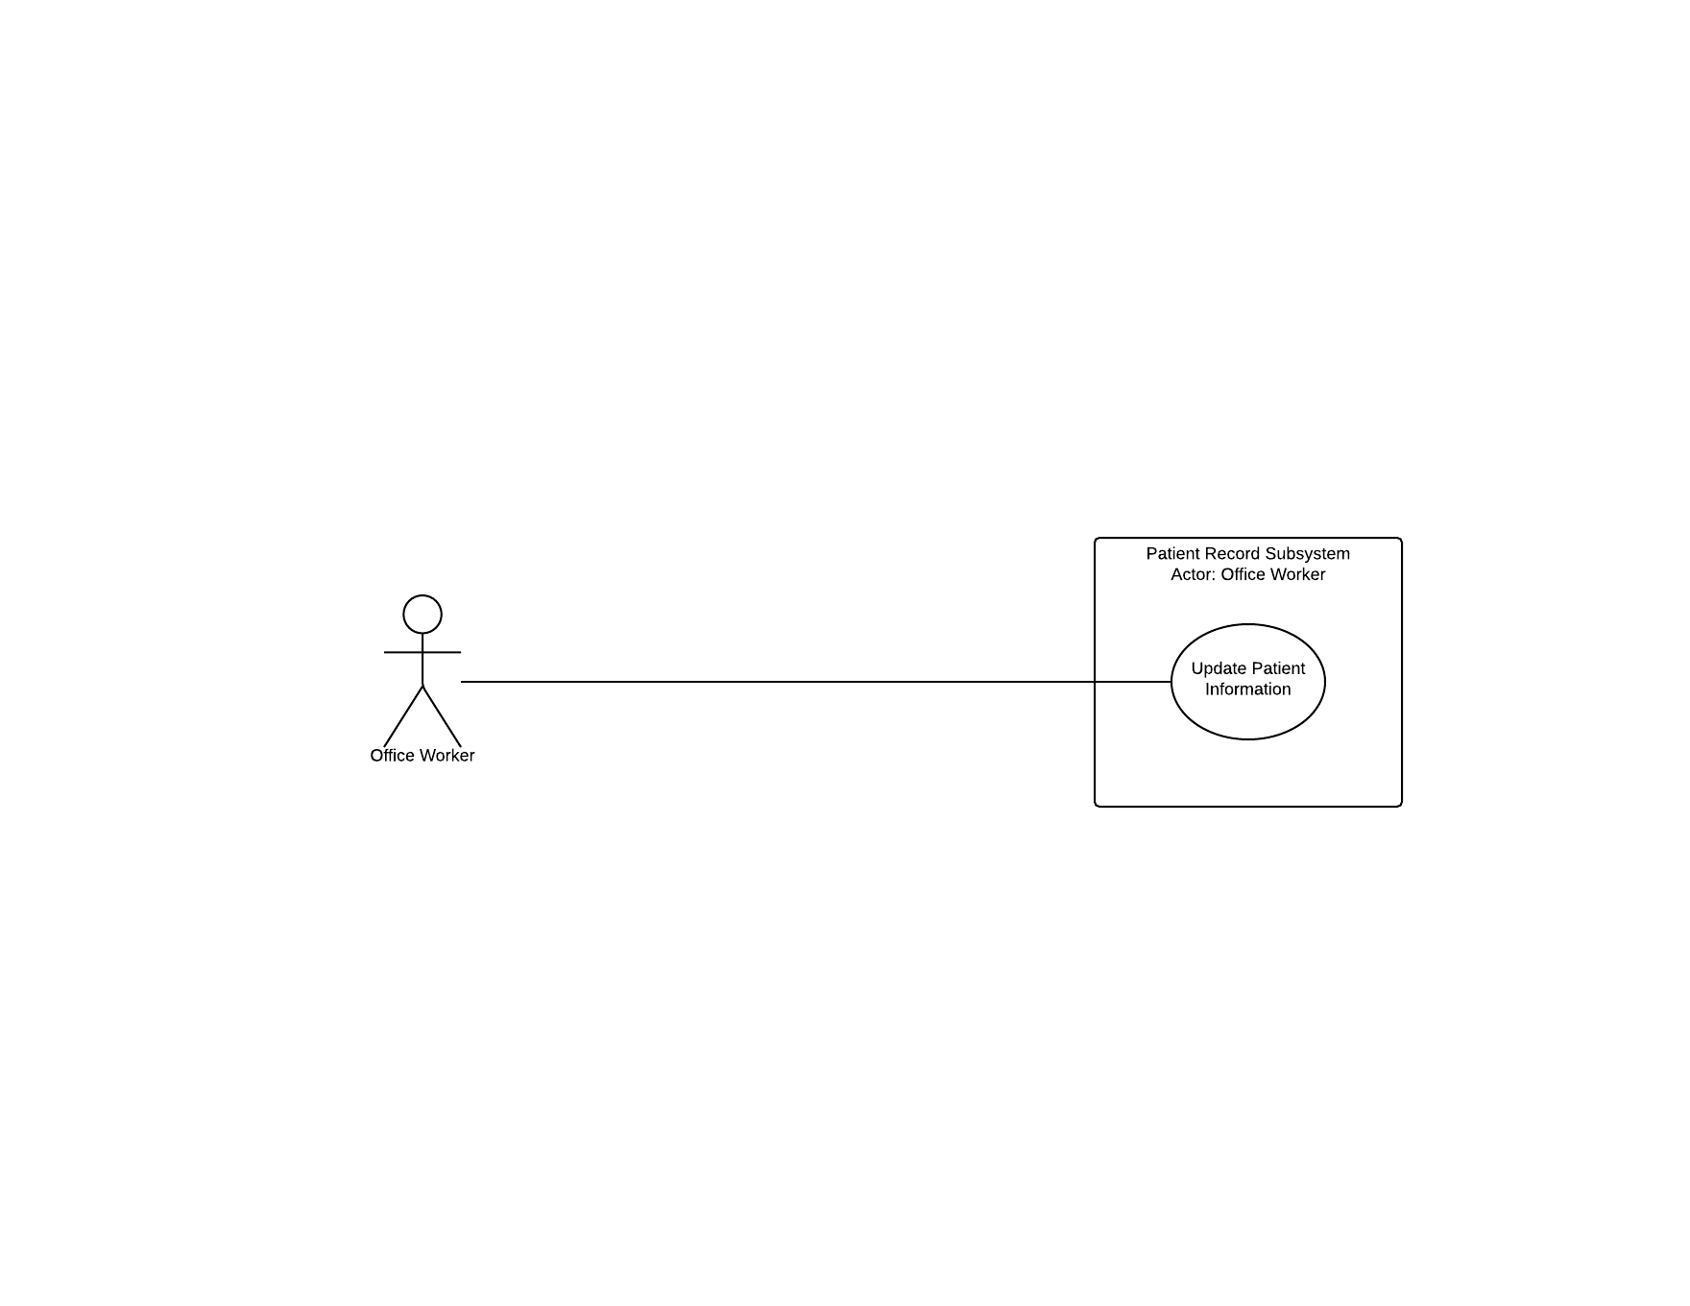

Here is the logic that goes into this process. After the patient is specified, a check is made to make sure it doesn’t already exist (if it does exist, the user is prompted to make a new choice). If it does exist, the user is prompted for new information, and the patient is updated.

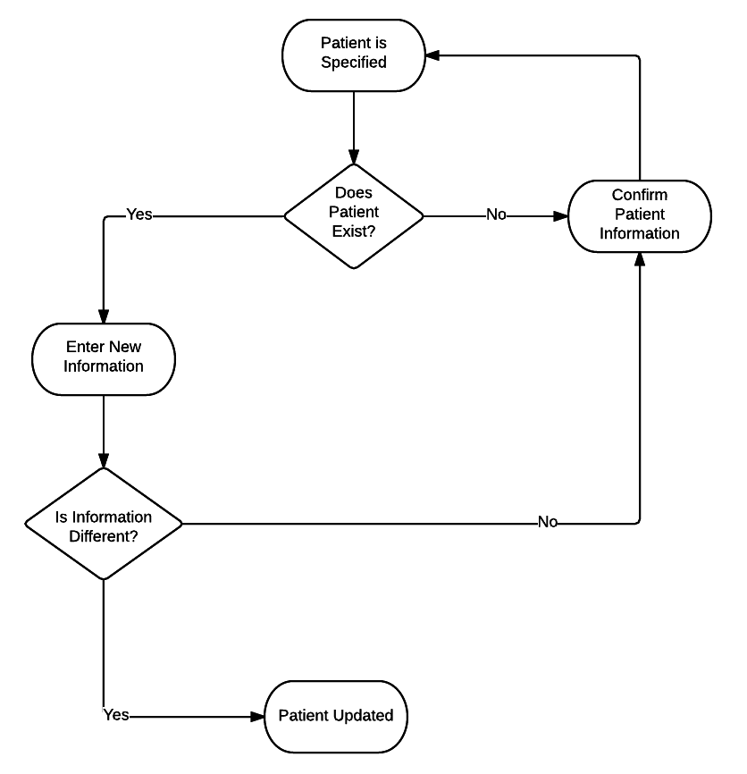

Finally, we have the sequence diagram. This sequence requires accessing information in the Patient class. After supplying the patient to update, the user is prompted for new patient information. After sending the changed info, the user receives confirmation of the update.

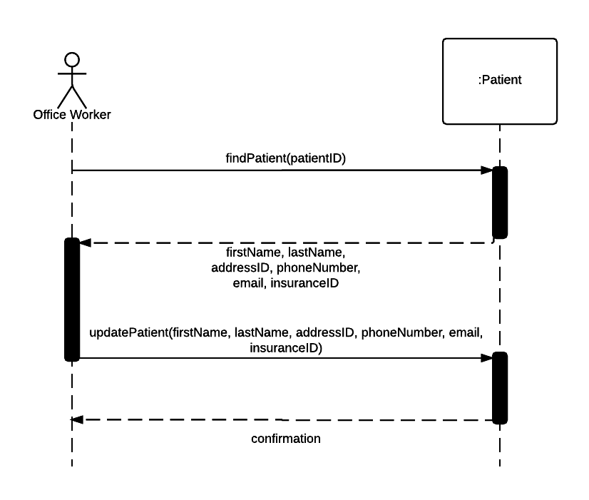

### Primary Use Case Detailed Descriptions

Below we fully explain each primary use case with a full case description. The details for each case are contained with each table.

|  |  |
| --- | --- |
| Use Case Name: | **Patient Scheduling Subsystem** |
| Scenario: | Create new appointment |
| Trigger Event: | Patient calls/walk ins to make appointment |
| Brief Description: | The office worker must create a new appointment using the scheduling subsystem |
| Actors: | Office Worker |
| Stakeholders: | Office worker |
| Precondition: | The office worker must verify that there is a free time/date in the schedule to create a new appointment. |
| Post condition: | The office worker should remind the patient of the upcoming appointment when it nears the specified date. |
| Flow of activities (Actors): | 1. Patient walks in/phones office to create appointment 2. Office worker looks for available date on the scheduling system 3. Patient picks specified date 4. Office worker confirms with doctor 5. Office worker creates the appointment and hands out card/tells the date and time over the phone 6. Office worker reminds patient before specified date |
| Flow of activities: (System) | 2.1 System searches the database to look for available date  5.1 System creates new appointment in which it is stored in the database for further reference  6.1 System reminds the database that an appointment is nearing |
| Expectation Condition: | 1.1 f patient tells the office worker that they need to reschedule the office worker must have to reschedule to a better date/time  2.1 If the office worker must have to reschedule to unexpected conditions they must reschedule with the patient immediately |

|  |  |
| --- | --- |
| Use Case Name: | **Patient Record Subsystem** |
| Scenario: | Create a new patient |
| Trigger Event: | New patient arrives |
| Brief Description: | The office worker must create a new patient into the Patient Record Subsystem |
| Actors: | Office Worker |
| Stakeholders: | Office Worker |
| Precondition: | The Office Worker must make sure that the new patient is not already in the system by searching by his/her last and first name |
| Post condition: | The worker should confirm all the information before entering into the system with the patient |
| Flow of activities: | 1. New patient arrives at clinic 2. Worker makes sure if the patient has a health card 3. Worker checks if the patient isn’t associated anywhere else before going through the process adding the new patient to the system 4. Worker asks for personal information and allergies if any and what medication they are currently taking. 5. Worker confirms with patient 6. Patient is added to system with a new Patient ID number |
| Flow of activities: (System) | 3.1 Database searches other systems to see if patient isn't associated with another one  4.1 System updates the personal information that the worker has entered into the database  6.1 Database is updated with new patient ID number |
| Expectation Condition: |  |

|  |  |
| --- | --- |
| Use Case Name: | **Office Order Management Subsystem** |
| Scenario: | Update Office Inventory |
| Trigger Event: | Low supplies in inventory |
| Brief Description: | Office worker update the system when new order supplies arrives to the clinic |
| Actors: | Office Worker |
| Stakeholders: | Office Worker |
| Precondition: | Office worker must regularly check the inventory to see what’s getting low and needs to ordered |
| Post condition: | After supplies arrived they must immediately be updated |
| Flow of activities: | 1. Worker regularly checks inventory 2. If supplies is getting low the worker must order it immediately 3. When supplies arrive the worker must update it as soon as it stored in the right place |
| Flow of activities: (System) | 1.1 Database tells the user how much supplies is available  3.1 Database is updated with current inventory |
| Expectation Condition: |  |

|  |  |
| --- | --- |
| Use Case Name: | **Patient Record Subsystem** |
| Scenario: | Update Patient Information |
| Trigger Event: | When patient personal information changes (Home address, phone number, allergies, medication) |
| Brief Description: | If the patient information changes it must be updated immediately. |
| Actors: | Office worker |
| Stakeholders: | Office Worker |
| Precondition: | Look up the patient via there patient ID # |
| Post condition: | Change the requested information |
| Flow of activities: | 1. Patient walks in/ phones office 2. Patient tells the worker what has changed since the last visit 3. Office worker updates the personal information in which the patient has told them to change 4. Worker confirms with the patient before updating the information to the system |
| Flow of activities: (System) | 3.1 System searches the patient ID for their ID  3.2 Database brings up patient ID and the system changes what is requested to change |
| Expectation Condition: |  |

|  |  |
| --- | --- |
| Use Case Name: | Patient & Insurance Billing Subsystem |
| Scenario: | Receive Funds (Insurance Company) |
| Trigger Event: | Appointment is finished and the patient is billed and office worker pulls up their insurance. Worker then sends information to insurance to how much is covered. |
| Brief Description: | If the patient is charged after an appointment the insurance agent will receive the invoice. |
| Actors: | Office Worker, Insurance agents, All agents |
| Stakeholders: | Office Worker, Insurance agents, All agents |
| Precondition: | Make sure the patient has insurance and it is valid |
| Post condition: | Worker charges the patient of what % is covered from the insurance company |
| Flow of activities: | 1. Patient finishes appointment 2. Office worker looks up the patient ID with their insurance 3. Office worker sends copy of recipient to the insurance company/agent so they know how much was charged and how much was covered 4. Patient pays the reminder (if any) 5. Patient fills out form at home if they do not have information on hand |
| Flow of activities: (System) | 2.1 Systems searches in database for patient ID |
| Expectation Condition: |  |

# SYSTEM COMPONENTS DETAILS

## PROGRAM DESIGN

### Design Class Diagram

A fully designed class diagram is shown below. We include all identifiers, datatypes, methods and parameter values as a well-designed diagram should include, via UML standards.

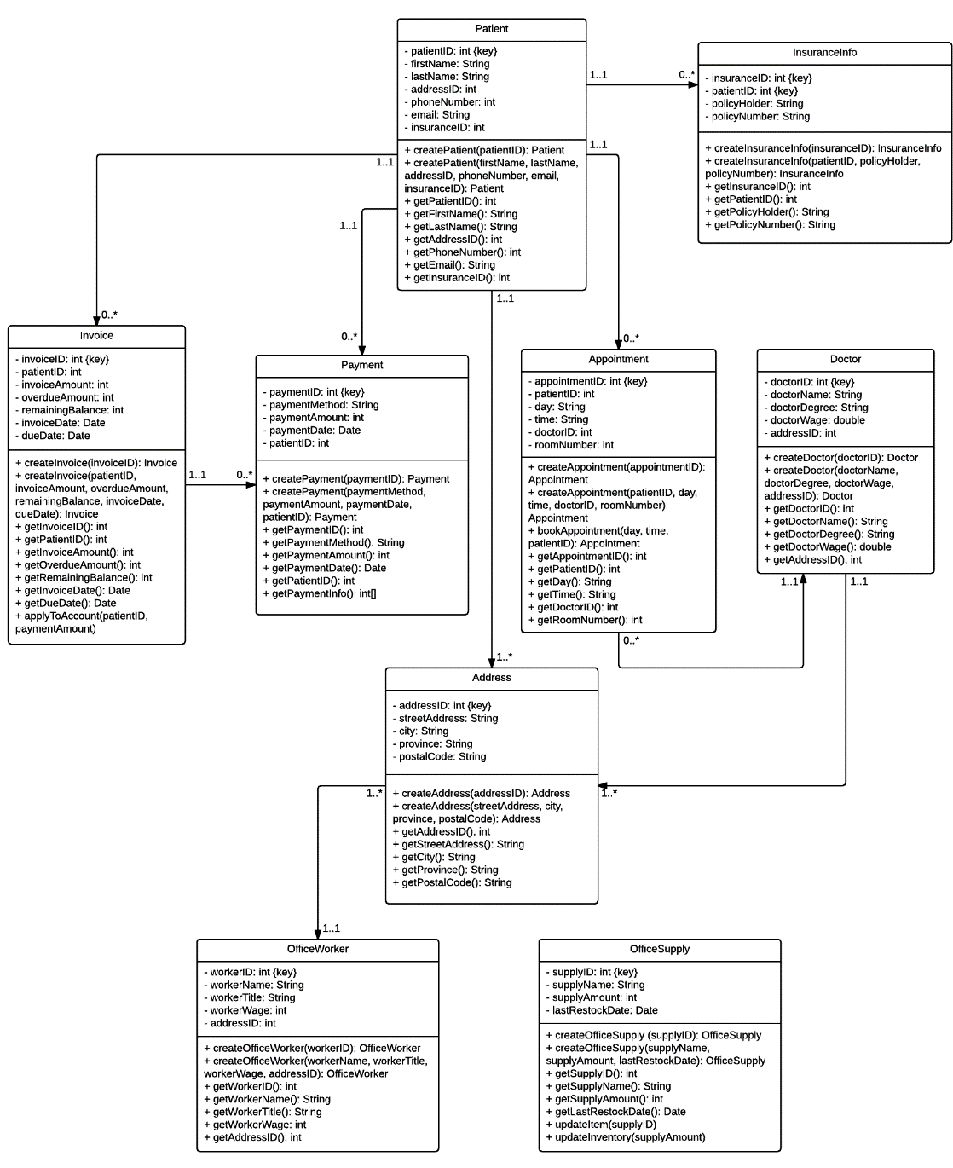

### Sequence Diagram

A sequence diagram represents the messages being passed to each object within the system itself at different layers. As it passes between those layers, it shows the multi-tier aspect that an application contains.

In looking at the sequence diagram you will notice that the flow starts with the patient and ends with the doctor. The patient either comes in for a scheduled appointment or the patient will come in to have an appointment created.

If the appointment is created then the front reception will handle the scheduling of the appointment. The scheduler will display all available dates back to reception and reception will choose the next available date. The patient will then be notified of the scheduled date. If for some reason the next available date is not suitable for the patient then reception will just simply choose another date from the scheduler.

If the patient is coming in for a scheduled appointment, reception will verify the appointment taking the patient’s pertinent information and notifying the doctor that the patient has arrived.

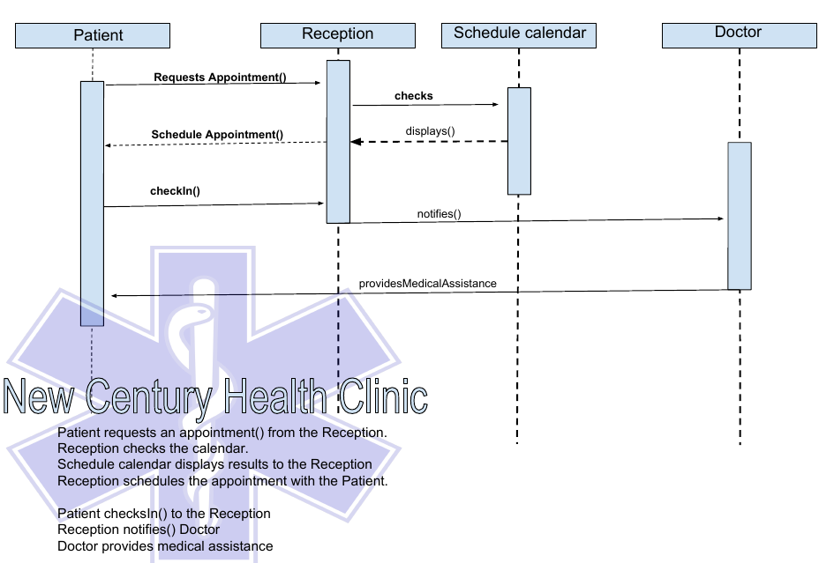

### Package Diagram

Two cases that were picked for the package diagram were the patient case and the appointment case.

These seemed to be the most pertinent, as the patient case contains all the information pertaining to the patient’s personal and medical data. The appointment object relates to the scheduling and billing of insured and non-insured patients.

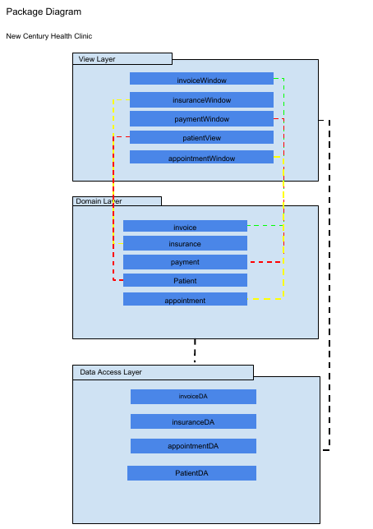

## INPUT DESIGN

### User Interface Designs

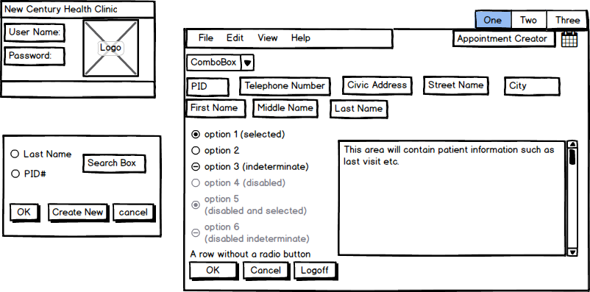

* New Century Health Clinic logon screen with field for their Username and Password
* A screen will pop with a search feature by either searching by Last Name and then would populate the information in which you selected in the fields to the right.
* You can also by Patient ID if you know and then it auto populate the information in the blank fields
* On the top right you would have an appointment Creator in which you can choose what date to book the patient and see what time and days are available
* Ok, Cancel, and logoff for user
  + If pressed cancel it will ask you “If you are sure you to delete unsaved information?” and will pop yes or no
  + If pressed ok it will submit your information you entered
  + If pressed logoff it will take you back you to the main screen
* Top Menu
  + File would contain either reviewing an appointment, creating or modifying
  + Edit will modify the program itself with language, font, size
* View would allow to view current appointments made
* Help – would include the manual to the program itself including shortcuts and support if there is a bug an email/phone number to reach support

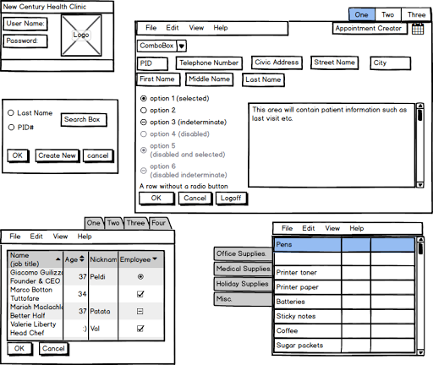

* Clicking tab one, two or three would take you to the insurance or medical supplies selection
* The supplies tab would show much inventory is available so you can keep track of what's getting low
* The insurance tab on the bottom left would contain the name (job title),the name and what insurance provider

## OUTPUT DESIGN

### Report Analysis

Below we have embedded each analysis for every required report. You can easily review by double clicking on the chosen document. These documents will outline the structure of every mock-up completed.

|  |  |  |  |
| --- | --- | --- | --- |
| Daily Appointment List | Insurance Report One | Insurance Report Two | Medical Supply Inventory Report |
| Mailing Labels / Post Cards | Patient Reminder | Patient Statement | Weekly Provider Report |

### Report Mock-Up Descriptions

#### Daily Appointment List

The appointment list is optimized to allow office staff to quickly and efficiently see patient scheduled times for their given appointment. As is stated in the report analysis, the list is ordered by last name alphabetically for quick searching.

#### Insurance Report One

This report is otherwise called “Weekly Insurance Company Report “. This allows New Century to view the number of submissions, claims and policy holders for each and every insurance provider in one easy to read document.

#### Insurance Report Two

Insurance Report Two is also known as “Monthly Claim Status Summary “. This report will detail more financial information (MTD and YTD) than its counterpart report (Insurance One).

#### Medical Supply Inventory Report

Inventory is of particular concern when developing a report for medical supplies. The document must show how at minimum the quantity on hand and acceptable amounts that the clinic should carry. To optimize the view of the report, it is primarily ordered by QoH.

#### Mailing Labels / Post Cards

Post card reminders and labels are a necessary for the clinic for two reasons. The first is to provide that sense of “we care about you“, to their clients. The second is that, when a patient misses an appointment, it wastes the clinics time and money. So, the reminder is utilized for preventative measures.

#### Patient Reminder

A call list that can be used by office workers to contact patients about their upcoming appointments. The list can be followed from the beginning to the end as it will be ordered by patient appointment date. The telephone number is placed to the right for each patient listing.

#### Patient Statement

A statement is a staple report. It ultimately shows how the company is organized, how professional they are and how much they care about their clientele. A statement should be as clear and concise as possible with areas of interest (such as the patient balance and insurance claim information).

#### Weekly Provider Report

This report displays data on the clinics health providers and how much each provider has charged to the clinic based on appointments. This also shows the values as MTD and YTD.

### Report Mock-Ups

|  |  |  |  |
| --- | --- | --- | --- |
| Daily Appointment List | Insurance Report One | Insurance Report Two | Medical Supply Inventory Report |
| Mailing Labels / Post Cards | Patient Reminder | Patient Statement | Weekly Provider Report |

## DATABASE DESIGN

### Entity Relational Diagram (ERD)

The ERD is the initial view of the database structure. Developed through the use of the design class diagram, the relationship between each object coincides with our design. Tables were implemented to ensure that specific types such as ‘Employee Type’ and ‘Invoice Type’ were isolated and associated with the related entities. This will allow for different types to be added in the event that there is a need, thus promoting scalability.

‘Doctor Assignment’ is an entity that will only contain employees with a specific employee type of ‘Doctor’. Each doctor will be assigned to an appointment ID.

‘Office Supply’ is an entity outside of the main structure that relates only to the office supply management system.

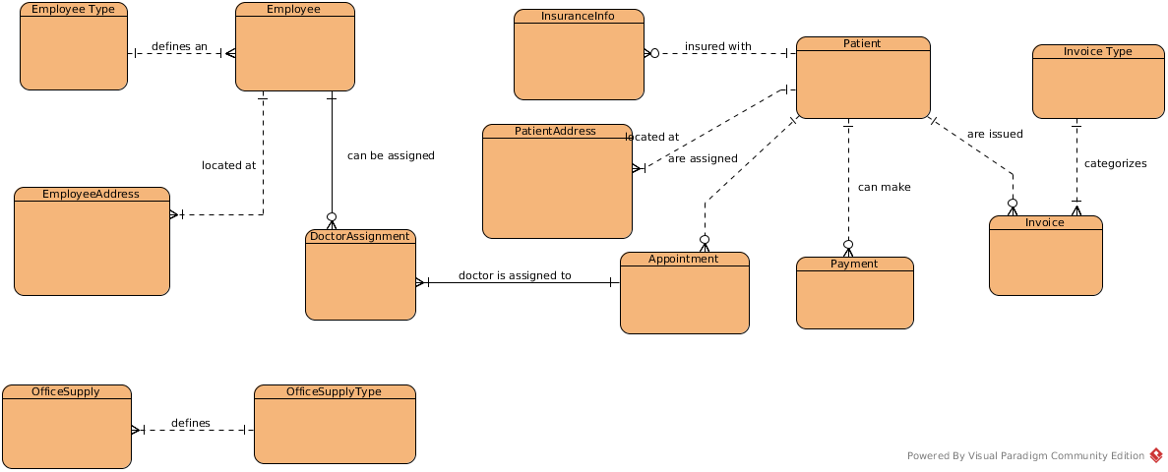

### Database Description Language (DBDL)

DBDL represents the layout of each entity contained within the above ERD. In a sense, this reads is much like a software development language. It has a basic syntax and pattern to how it flows. The database design implemented for New Century can be fully integrated with the use of the below description.

EmployeeType( EmployeeTypeID, EmployeeTypeLong, EmployeeTypeShort )

Employee( EmployeeID, EmployeeTypeID, Firstname, Lastname, Phone, Email )

|  |
| --- |
| FK EmployeeTypeID → EmployeeType |

EmployeeAddress( AddressID, EmployeeID, StreetAddress, City, Province, PostalCode )

|  |
| --- |
| FK EmployeeID → Employee |

OfficeSupplyType( SupplyTypeID, OfficeSupplyTypeLong, OfficeSupplyTypeShort )

OfficeSupply( SupplyID, OfficeSupplyTypeID, SupplyName, SupplyAmount, lastRestockDate )

|  |
| --- |
| FK OfficeSupplyTypeID → OfficeSupplyType |

Patient( PatientID, Firstname, Lastname, AddressID, Phone, Email )

InsuranceInfo( InsuranceID, PatientID, PolicyHolder, PolicyNumber )

|  |
| --- |
| FK PatientID → Patient |

PatientAddress( AddressID, PatientID, StreetAddress, City, Province, PostalCode )

|  |
| --- |
| FK PatientID → Patient |

Appointment( AppointmentID, PatientID, Day, Time, RoomNumber )

|  |
| --- |
| FK PatientID → Patient |

DoctorAssignment ( EmployeeID, AppointmentID )

|  |
| --- |
| FK ( EmployeeID, AppointmentID ): Composite Key |

Payment( PaymentID, PaymentMethod, PaymentAmount, PaymentDate, PatientID )

|  |
| --- |
| FK PatientID → Patient |

Invoice( InvoiceID, PatientID, InvoiceTypeID, InvoiceAmount, OverdueAmount, RemainingBalance, InvoiceData, DueDate )

|  |
| --- |
| FK PatientID → Patient, InvoiceTypeID → InvoiceType |

InvoiceType ( InvoiceTypeID, Invoice TypeLong, InvoiceTypeShort )

### Data Dictionary for New Century Clinic

A detailed dictionary of all data attributes that can be found in every table. This will be implemented into the database design and structured to handle all data requirements.



### Final Table Views w/ Relationships

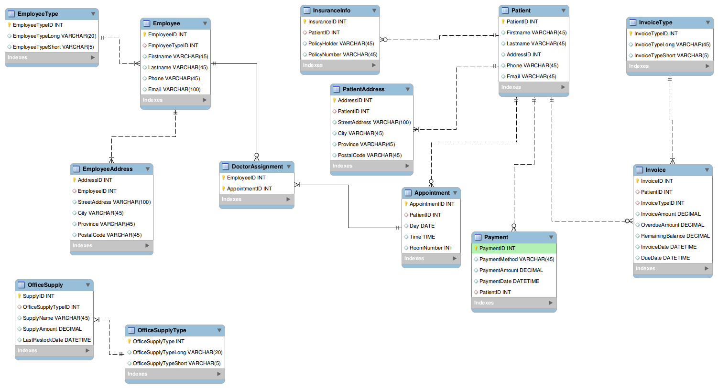

## SUPPORT PROCESSING DESIGN

### Physical Form Documentation

The following documents have been produced in order to provide a streamlined process for entering data into the HuMorIST information system. Physical based documents will ease the data entry transition from real world data into a computerized system.

* Medical Psychiatric Referral Form

Utilized when someone wishes to refer someone into psychiatric care.

* New Patient Form

Used to register a new patient with the clinic and create a new health record.

|  |  |
| --- | --- |
|  |  |

### Policies & Procedures

Online processing

Handles data and provides an immediate output. Online processing provides an interactive and continuous channel for dialog between the system and the user.

Batch processing system

Generally batch processing is used for large quantities of data that is processed a on a regular basis, such as pay checks and medical billing, which would be valuable for New Century Health clinic for these reasons. Batch processing groups input transactions so they can be processed together. The overall characteristics of this system are to collect, group, and process transactions periodically.

There is a way to utilize both methods of processing, and this combination would produce positive results for NCHC. Online processing would be used for things such as scheduling where you would get instantaneous output and updating. The moment the receptionist makes an appointment on the computer the system it will save the information and update the current available time slots. Batch processing would be used specifically for things like medical billing and paycheck transactions, which are high quantities of data that need to be processed regularly.

Further policies and procedures that relate specifically to government related health organizations can be found within the appendices. These documents outline specific regulations for information systems that deal with sensitive health related data.

### Financial concerns and considerations

The systems analysts estimated the cost of implementing the information systems. We have decided to hire 12 programmers. Three for each proposed system (DSS, TPS, Inventory system, and Patient profiling system). With IT Professionals/ programmers costing $259,200 in 9 months, training cost would be $20,000 in 2 weeks, hardware cost are $3,500 for 7 computers, software installation and licensing amounts to $2,100 and system consultation and maintenance costs are about  $5,000. The total cost of implementing information system is $289,800

Cost of implementing information system (effective 5 years)

|  |  |  |  |
| --- | --- | --- | --- |
| **Items** | **Units** | **Price** | **TOTAL** |
| IT Professionals/ Programmers | 12 programmers  3 programmers per system | ($20hr/person) for 9 months | $259,200 |
| Training cost | 2 weeks | $10,000 per week | $20,000 |
| Hardware cost | 7 computer sets | $500 per unit | $3,500 |
| Software installation and licensing | 7 operating systems and licenses | $300  Composed of operating systems and application software | $2,100 |
| System consultation and maintenance | Semi-annually for 5 years | $500 per systems check | $5,000 |
| **TOTALS** |  |  | **$289,800** |

The cost of hiring an estimate of one additional staff per year in 5 years added up to $316,200 if each staff is paid $8.50 per hour plus other expenses like training expenses and others.

 Cost of hiring an estimate of one additional staff per year (effective 5 years)

(Assuming that each staff is paid $1,740/month, training expenses of $600/staff, etc)

|  |  |  |  |  |  |  |
| --- | --- | --- | --- | --- | --- | --- |
| **Year** | **Staff/s** | **Salary/day**  **(8 hrs. a day)** | **Monthly Salary** | **Yearly Salary** | **Other Expenses (training, insurance, overtime)** | **Totals/ year** |
| 1 | 1 | $58 | $1740 | $20880 | $3000 | $23880 |
| 2 | 2 | $116 | $3480 | $41760 | $6000 | $47760 |
| 3 | 3 | $174 | $5220 | $62640 | $9000 | $71640 |
| 4 | 4 | $232 | $6960 | $83520 | $12000 | $95520 |
| 5 | 5 | $290 | $8700 | $104400 | $15000 | $119400 |
| **TOTAL for 5 years** | | | | | | **$358200** |

The table above shows the computations of implementing information systems and hiring additional staffs. From the table, the systems analysts have concluded that it is better to implement new information systems for the efficiency and accuracy of the clinic systems.

           As shown in the tables, the cost of installing a computerized information system would cost $289,800 and the cost of hiring new staffs would cost $358,200. Installing a computerized information system will not only save the company $68400 but also make the work load of each employee considerably lighter, also giving the company a more efficient way of keeping track of the patients’ medical history and personal information.

## ENVIRONMENTAL REQUIREMENTS

### Hardware & Software Requirements

We believe an Internet-based architecture produces numerous beneficial factors. The Internet has become more than a source of communication, but has altogether changed the environment of system development. The Internet has opened so many doors of possibility. In the case of client-server systems, the client handles the user interface. By utilizing the Internet in the system, the entire user interface would be provided by the web server. Documents would be in the form of HTML coding which would then be translated and displayed by the client’s browser. This is just like the way many websites appear and perform on an average computer with Internet accessibility.

The result of using the Internet-based architecture as opposed to the client-server systems is a shift in responsibility for the interface, becoming the server’s responsibility rather than the client’s. This is key for New Century Health Clinic, as it would produce a simplified process for data transmission, which ultimately results in a decrease in cost for hardware and other data transmission difficulties.

E-business provides cost-effectiveness, overall efficiency, and reliability. It has reshaped business as an industry. Advances are continuously made, launching Internet-based architecture into a modernized realm, where demand for e-business is high. New Century Health Clinic should consider Internet-based architecture for their system, as it would open the door for many future possibilities, such as online scheduling, online links to pharmacies, and more. The Internet would increase communication accessibility overall.

A client-server system that integrates the use of internet protocol seems to be a better choice for New Century Health Clinic than a file-server design. Client-server architecture allows for more precise data transactions, as a specific request renders a specific result. In file sharing, only an entire file can be exchange, not a certain excerpt according to the clients query. For example, in the client-server architecture, if the receptionist wants to view Jane Doe’s medical billing records, she can view these individual records upon request (if security measures allow). If the system had a file-server design, the receptionist would have to view the entire document of billing for all patients.

Along with this, the file-server design utilizes a significant volume of network resources, rendering it efficient, only when network users are low and data processing is small. Being a medical practice, it is nature for New Century Health Clinic to have a large quantity of data that needs to be shared frequently, despite the fact that there is only four personal computers which is a relatively small amount of network users.

If client-server architecture incorporates a local area network (LAN) into its systems functions, it would allow for the transfer of data between computers, along with making the high-speed laser and impact printers and the tape backup unit accessible by all four PCs that would be connected to the system.

### Facility additions and modifications

Implementing a new system over a legacy system is an important task. The way it is conducted is even more important. One can either do a direct cutover which literally flips a switch and shuts off the legacy system for the new. This approach is fast, but could have drastic consequences, such as errors not yet found or system failures right in the middle of conducting business.

MedCode’s recommended changeover method would be the pilot system which will test one section/module of the new system at a time, while running the legacy system in the background. This process will provide the least amount of risk as we will be able to try out the new system features and reference back to the old, while conducting normal business. This will also help train new staff in the process. The first system to go through the pilot changeover should be the patient scheduling system, patient record system, and the patient and insurance billing systems.

### Deployment Diagram

Hybrid system using cloud services as well as in-line server hardware. Cloud backup services will adhere to all HIPPA standards.

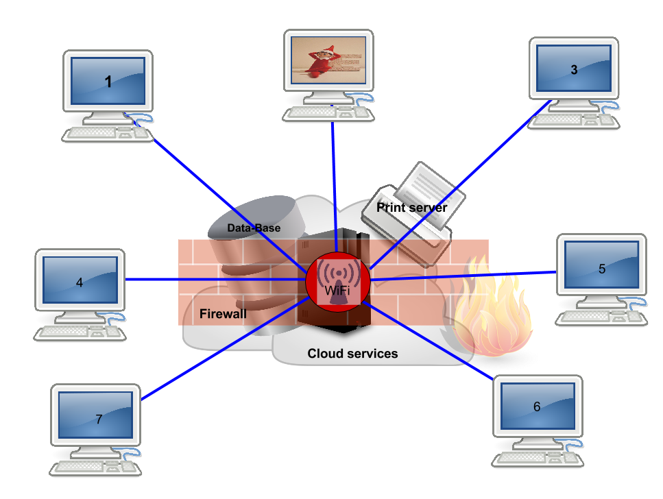

## IMPLEMENTATION REQUIREMENTS

One of the largest barriers in the health industry is when there is a requirement to change over from a paper based practice of patient records to an EMR standard. The process can be extremely time consuming and cause further issues if it is not implemented and managed correctly. To ease this transitional process, we have outlined a guide for data conversion procedures based on best practice documentation available.

### Data Entry

With the sensitivity of patient record information, data entry is a single effective means to process all records into a digital form. The amount of data per record can cause this process to endure for an extended period of time and also become an expensive task. All paper documentation required to be processed into the new system should be kept available for at least a six month period after the confirmation that all data is processed. This will allow a failsafe in the event that data was not submitted correctly. Below, we recommend the following steps to be taken into consideration for data entry processes:

* It should be necessary to decide what information will be entered manually and what will be digitally scanned. As both methods have their uses, this should be determined prior to any entry into the system. Certain data present on physical documentation that is digitized, may need to be altered.
* Patient records that are utilized by New Century on at least a daily basis or as a higher than normal frequency (determined by New Century) should be placed first to be entered into the system. This will allow staff access to the most used data first and foremost
* Specific fields that are documented as 'regularly required during a patients visit' should be considered for initial entry as well. These fields are generalized and may fall under similar categories.

|  |  |  |  |
| --- | --- | --- | --- |
| Allergies | Current Problems | Current Medications | Past Medical History |
| Surgical History | Lab Results | Consultation Letters | Immunizations |
| Screenings | Test Dates / Results | Pathology | Recent EKG's |

* Patient records that are utilized by New Century on at least a daily basis or as a higher than normal frequency (determined by New Century) should be placed first to be entered into the system. This will allow staff access to the most used data first and foremost

### Digital Document Creation

Digital records and images are an essential part of any new EMR system. There are also pros and cons that must be considered when scanning is a choice of implementation. To provide insight into this method, we have outlined the following points below:

* Digital documentation such as in the format of PDF or any image specific type will not be usable in any plain text based fields that are available via user interfaces. This should be reviewed as some data used would likely be changed in regular intervals.
* A well-documented procedure should be established and reviewed for placement of all digital documentation and imagery into the system. This is so that for future documents, all policies and procedures are adhered to by end users.
* All paper based records and charts would not be required once verified that they have been digitized (although this decision is left to New Century). The space once occupied by these documents can be utilized for other purposes.

### Security and Levels of Access

With regards to the secure nature of health record information, an appointed member should be placed in charge of all security policies and procedures upon deployment of this system. Responsibilities should include the management of access to the system, ensuring that policies and procedures are followed, and defining classifications for specific data types. Security recommendations and considerations are listed below. These recommendations are outlined by supporting legal documentation ( See Appendices > References > Canada Health Infoway ).

### Access Control

* Verification of credentials (user name and password) prior to access of the system, must be completed in order to gain any privileged access.
* Any violation of such access and/or lockout must be handled by an authoritative staff member to regain access
* Levels of access to data should be determined based on user requirement to fulfill their roles and duties. Any additional access is restricted unless overridden by authoritative management personnel. These levels can be determined based on file usage prior to system implementation or can be defined further by limiting scope.

### Data transfer and usage

* All electronic data transferred to and from the system must be encrypted to prevent unauthorized access to it.
* All portable media that is used by authorized users must be encrypted and password protected in the event that it is lost or stolen.
* All transactions produced with all patient data (and any other information considered by New Century) should be logged for security and management purposes.

### Physical and Environmental Security

* Areas where system components reside should be safeguarded with a form of security measure to unauthorized physical access (man-trap, surveillance cameras, etc.).
* To manage any environmental hazards from damaging system components, preventative measures should be in place in case of fire, flood, and electricity.

### Contingency Strategies

* An incident response, disaster recovery and business continuity plan should be developed in the event of complete system failure or destruction.

### System Changeover Approach Recommendations

Deployment of the new system must be carefully brought into the working environment due to many factors. The employees who will be utilizing the system must be made fully aware of the time frame that it is brought on line. This should include the patients as well because of their expectations and knowledge of how the clinic functions. They are a customer ultimately and their faith is placed on the clinic to inform them of any changes to their private information. There should be some deal of consideration placed regarding resentment towards the new electronic system. As the original architecture was paper based only, there is a high likelihood that staff will not wish to utilize the electronic form. This must be enforced if the need arises and the importance stressed on how it will assist everyone in the future. Below, we describe two methods of deployment that we recommend for system changeover. The systems involved shall be the following:

* Patient Record System
* Patient and Insurance Billing System
* Patient Scheduling System
* Office Order Management System

#### DIRECT DEPLOYMENT (ALL AT ONCE / BIG BANG)

The method of direct deployment is certainly the most simplistic method of the two described. It is a recommendation to be used when staff have been made aware and are fully capable of working with the system after training and documentation reviews. Once sufficient testing has been completed and is believed to be 'user ready', we would highly recommend this option of integration.

#### PHASED DEPLOYMENT (STAGED ROLLOUT)

A phased roll out of each system implemented can be easier to deploy for staff, if they are not fully aware of all features and functionalities yet for each system being developed. These systems could be brought on line one at a time to allow users time to adapt. Resolving any system conflicts that may arise would be lessened in this manner as opposed to a fully direct deployment.

### Training Requirements

As employees moving to a fully electronic environment from paper, there is a training requirement that must be fulfilled, so that it allows them to continue to work proficiently and with reduced stress levels due to change.

A training schedule should be implemented for all staff required to access the system. A listing of items that would be required is as follows:

* General computer training ( in accordance with the specific OS platform used )
* Patient Record System
* Patient and Insurance Billing System
* Patient Scheduling System
* Office Order Management System

Users of the system must be defined in one of two categories. They would be trained as either an ' end user ' or a ' system operator '. There is a significant difference between both titles in terms of user access and knowledge of the systems functionality. We define both types below:

|  |  |
| --- | --- |
| End User: | A user with a specific skill set would is assigned access to all user interfaces that would relate to the use and need of their position. |
| System Operator: | Responsibilities of maintenance for the system, perform backup and recovery procedures. Possibly some administrative tasks could be assigned. |

### Post-implementation review

As it has been noted, the change from paper to digital formats is a rather large one. During any recommended deployment phase with this intended system, it must be known that paper documentation would still be available for use and may be received from an external source outside of the system environment. To ensure that this is handled correctly and will not jeopardize the integrity and availability of the data, a procedure should be implemented in order to handle such cases. Also, all system downtimes should have a strategy to apply.

## IN-HOUSE VS. OUTSOURCING RECOMMENDATIONS

### Similar products in the industry

**Technical Feasibility**

The management will need to review the proposed system being used. It is to add hardware to the current system for the increasing workloads. The hardware will not function without the support of the software and network resources.

The hardware being stated above consists of the devices that support the data that are going to be entered, displayed, stored, and be processed. The memory capacity of the computer is also considered in the hardware for the system that is going to be used.

Software has instructions that are executed by the computer. This includes the system software which controls the operations of other software. It has the operating system which is the most important part. It directs the operation of the computer and the utility software is responsible for the computers’ day-to-day operations. Application software includes the Decision Support System (DSS), Transaction, Processing System (TPS), Inventory Management System (IMS), and the Patient Profiling System (PPS).

Network resources are resources that support the software and hardware. It also allows the user(s) to work together in the browser for scheduling, electronic mailing and messaging. The company’s website also allows the customers to have users communication with the management for appointments or if they wanted to have some additional information.

Management could hire I.T. professionals for the installation and for the preliminary tests on the system being proposed. This can be acquired through advertisements, newspapers, flyers, bulletins, or online advertisements using the clinic’s website.

The system being proposed is upgradeable and being maintained because of the increasing number of customers and also for the ease of use in the near future.

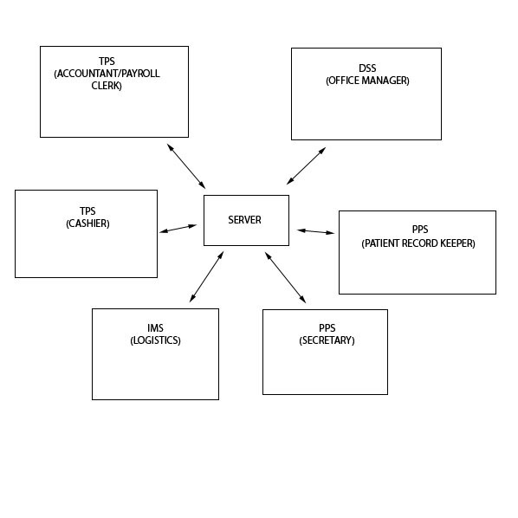

**Operational Feasibility**

Management has requested to change their current system used for keeping track of patients, appointments, charges, and insurance claims. The change of this system is needed in the clinic because the number of patients continues to increase and rather than hiring more staff for a temporary fix of the problem, management has decided to put a more permanent end to the problem.

The proposed system will not only reduce job tasks for the associates but will also reduce the need to hire more staff in the near future.

Staff are going to be involved in some of the decision making progress in regards to what they need the system to do, and how we can be made to easier to do the job. The completed system will require the user to be properly trained on the software so that as experience grows, supervision will decrease. Every associate/user will have to be trained for their specific software which will require some time and possible extra training.

The proposed System Networking stated from the technical feasibility is explained in this portion from systems software such as Transaction Processing System, Patient Profiling System, Inventory Management System, and Decision Support System.

From the networking above, the server will be the medium for the different systems networking. Here are the explanations:

|  |  |
| --- | --- |
| Systems Software | Task and Connection |
| Transaction Processing System   1. Payroll Clerk/Accountant 2. Cashier | 1. Sends records of employee’s salaries and wages together with tax payments to the server. 2. Will input the payments received from patients as well as insurance fees then automatically stored to the server. |
| Patient Profiling System   1. Secretary 2. Patient Record Keeper | 1. Input of corresponding appointments schedules of the doctors and patients are stored to the server for both patient and doctor to view and can only accessed by the secretary. 2. The details of every patient are recorded in this system wherein information is saved to a database in the server; it can also be accessed by the record keeper alone. |
| Inventory Management System   1. Logistics Officer | 1. To track inventories, logistics officer records the left items and the ordering of other supplies in the database to be stored in the server at the same time. |
| Decision Support System Office Manager | 1. Has access to all the systems in the clinic. Therefore, all information of every system is sent to DSS by the server. In here, the office manager can evaluate the reports. |

The server is connected to all the systems in the clinic for the different types of daily transactions that place. It will also be the middle man to send/receive reports from system to system.

Patient files would be restricted to the one who is involved with or in-charge of the patient files such as a record keeper or secretary. The files would be accessed only by the permitted doctor or the patient. This allows for patient privacy during the transition from the old system to new system and allow for keeping the same business integrity that the clinic is already known for.

Problems that may occur in here are the time it takes for the system installation, its development and implementation and to keep the system running. It also adds up if the system complies with all regulations and laws of the management. The role of our proposed system is heavily based on security and keeping the customers happy, so the transition should not only be good for the clinic, but for the customers as well.

### In-house vs. Outsourcing approaches

The “Build vs Buy“question is forever being asked in all businesses that use IT daily. You can analogize the question with the purchase of a computer, with the development of a game engine, or even with a new table for your living room. All avenues need to be explored to produce a respectable answer is really the bottom line.

There is a six step methodology to follow when faced with the rather large decision.

Jumping to conclusions early on can lead to disaster such as failed implementations, data loss, and financial concerns if there was an existing system that was involved.

* Analyze software requirements
* Evaluate and select solutions(s)
* Negotiate purchase / lease arrangement with vendor
* Implement the solution
* Maintain and upgrade the software solution
* Maintain license, subscription and royalty fees

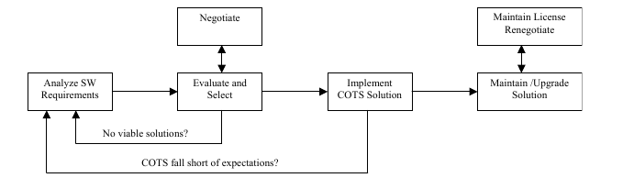

Appendices > References > In-house vs Outsourcing

Now, not all of the steps may apply to the decision being chosen, but it is important to

recognize that each is important in its own way whether an in-house solution is being debated or an outsourced choice. Initially you want to ensure that all requirements are fully investigated. Most of the time required to fulfill the decision would be placed here as you want to be sure of what you really need and what you don’t need for business processes. A detailed list should be developed and used throughout the process. Once completed, an evaluation of different products can be started. Options such as in-house development, outsourcing, COTS based (Commercial off the shelf software) and various others can be considered. Costs of each solution are also weighted into factors, time to implement, resources required, and whether there is a vendor involved in the choice. If so, does this vendor support their software for a given period of time, what is their track record with other businesses, etc. A negotiation phase may proceed in the event that a vendor does exist. Once completed, the next stage would be to implement the solution into the system. If it’s found that it does not fully meet the needs of the business, then it would be back to the drawing board effectively.

In-house development can certainly provide a custom product, but tend to me costly and resource intensive. Outsourcing to allow another organization to provide that service may resolve both of those negative factors that affect in-house development, but it comes with a price. There is sometimes no control over the services that are being provided. A certain “trust” would have to be established as you are allowing that business to use sensitive data that has meaning and value to your organization. While in our business, health information has a high privacy level, therefore an outsourced decision must be one hundred percent researched that it will not cause any future complications.

### Roles of committee members with New Century Clinic

As it pertains to the new information system, below we outline roles and responsibilities of stakeholders utilizing the system and how they should provide various inputs and outputs within the organization.

|  |  |  |  |
| --- | --- | --- | --- |
| **Job Title/ Position** | **Assumed role/ participation in the system** | **Input(s) provided by the stakeholder** | **Output(s) required by the stakeholder** |
| Office Manager | * View overall reports * Decision-maker | * Performance evaluation on reports provided by other stakeholders | * Give final decisions for the clinic activities |
| Cashier | * Handle financial transactions | * Receive payments of patients, medicine, services rendered, as well as insurance fees | * Issue receipts * Give reports on sales and payments everyday |
| Payroll Clerk/ Accountant | * Handle tax and insurance claims * Handle accounting reports | * Record employees together with their salaries or wages * Tax payment amounts * Overtime payments | * Employee salaries or wages report * Pay slips * Tax reporting * Stakeholders and patients’ insurance reports * Employee profit distribution report |
| Secretary | * Manage appointment book * Prepare daily appointment list | * Input patients’ appointments * Input all appointment schedules per day | * List of customer/patients’ appointments of the day * List of number of patients consulted |
| Patient Record Keeper | * Keep patients’ information | * Input accounts of patients and their insurance company if available | * Customer profile/information |
| Logistics Officer | * Order office and clinic supplies * Organize office and clinic supplies | * Input inventories and supplies needed | * Number of office and clinic supplies to be ordered * Supplies report |

1. **Office Manager**

The office manager has access to all the systems in the clinic. He/she first evaluates the reports given by other stakeholders then make final decisions on information such as ordering of additional supplies when supplies are empty and expansion of clinic when patients are increasing through the decision support systems (DSS).

1. **Cashier**

The cashier is responsible for the financial aspects of the New Century Health Clinic (NCHC) using the Transaction Processing System (TPS). He/she inputs the payments received and issues receipts afterwards. He/she also gives reports on the financial status at the end of the day.

1. **Payroll Clerk/Accountant**

The payroll clerk/accountant handles lists of employees/stakeholders. This includes the stakeholders’ personal information, their salaries or wages, tax payments, insurance companies, and others. He/she checks the insurance forms that needs to be claimed. He/she also makes employee salaries/wages report, tax report, employees and patients’ insurance report and others. The payroll clerk/accountant will use the Transaction Processing System (TPS).

1. **Secretary**

The secretary receives calls or online appointments and assigns each patient to the corresponding schedule and doctor. He/she inputs these schedules on the Patient Profiling System (PPS) which can be used to view the appointments for the day.

1. **Patient Record Keeper**

The patient record keeper maintains patients’ information. When new patient comes, the patient record keeper inputs all details about the patient including the patient’s insurance company through the Patient Profiling System (PPS). The information is then saved to a database. PPS can only be accessed by the secretary and patient record keeper.

1. **Logistics Officer**

The logistics officer is the one who orders and organizes office and clinic supplies. He/she waits the signal of the office manager for ordering additional supplies for the clinic. He/she uses the inventory management system (IMS) to track the current status of the office and clinic supplies.

# APPENDICES

### Supported Documentation

|  |  |  |  |
| --- | --- | --- | --- |
| Hardware Recommendations | | | |
|  | | | |
| Gate Protect Firewall | Dell Blade Server | Dell Business System |  |
|  |  |  |  |

### References

Canada Health Info way

<https://www.infoway-inforoute.ca/en/component/edocman/389-ehr-privacy-and-security-requirements/view-document>

HITECH’s Challenge to the Health Care Industry

<http://www.oracle.com/technetwork/database/security/owp-security-hipaa-hitech-522515.pdf>

PHYSICIAN GUIDELINES FOR ONLINE COMMUNICATION WITH PATIENTS

<http://policybase.cma.ca/dbtw-wpd/PolicyPDF/PD05-03.pdf>